Epicutis Product Website Guide
Prepared for The Elixir Vanity by Velaisance
This guide covers all 14 products returned by the Epicutis All Products collection on October 31, 2026. Each listing contains original website copy, manufacturer pricing, published sizes, ingredient information, directions, suggested search fields, and a matching original product image.

How to use this guide
Copy the customer-facing description, benefits, directions, and ingredient list into your product pages. Categories, tags, URLs, and SEO text are suggested website fields. Prices shown are Epicutis public retail prices in USD, not wholesale costs or confirmed Velaisance prices.
The accompanying image folder contains one original manufacturer image for each product, with descriptive filenames and an image index. Images have not been regenerated or enlarged. Confirm Epicutis retailer image-use permission and pricing terms before publishing.

Details to confirm before launch
- Enter your actual inventory, manufacturer barcode if applicable, tax settings, shipping weight, fulfillment details, and return policy. Do not copy the manufacturer’s store policies as Velaisance policies.
- Confirm Oil Cleanser sizing: its individual page says 4 oz, while the Cleansing Essentials Set lists 3.38 oz.
- Confirm travel set contents and individual sizes. Its description lists six product types, while the size line only lists 5 ml, 10 ml, and 15 ml without assigning them.
- Obtain corrected neck mask directions: the page repeats face-placement instructions. Confirm the eye mask pouch count and fill weight.
- Check current packaging for final ingredient lists, expiration or period-after-opening information, and warnings. The eye mask ingredient count does not match its displayed list. Hydrobiome Serum describes EWG verification as pending; do not advertise it as verified.
- For SPF, reproduce the complete current package Drug Facts, warnings, and directions before launch. The website text alone does not provide a complete label. Do not claim universal shade suitability or water resistance until confirmed.
- Use cosmetic appearance and hydration language. Do not add claims about treating disease, reducing fat, or replacing professional aftercare. Following procedures, use products only as directed by the treating clinician.

Catalog overview
Product | Retail USD | Website SKU
Luxury Skincare Set | $395.00 | EV-EPI-LSS-01
Cleansing Essentials Set | $105.00 | EV-EPI-CES-01
Lipid Serum | $250.00 | EV-EPI-LPS-01
Hyvia® Crème | $195.00 | EV-EPI-HYC-01
Lipid Recovery Mask | $125.00 | EV-EPI-LRF-01
Luxury On-The-Go Care Set | $175.00 | EV-EPI-OTG-01
Oil Cleanser | $85.00 | EV-EPI-OCL-01
Lipid Body Treatment | $225.00 | EV-EPI-LBT-01
Lipid Recovery Mask for Neck + Décolleté | $140.00 | EV-EPI-LRN-01
Arctigenin Brightening Treatment | $175.00 | EV-EPI-ABT-01
Lipid Recovery Mask for Eyes | $105.00 | EV-EPI-LRE-01
Hydrobiome Mist | $75.00 | EV-EPI-HBM-01
Lipid Shield SPF 30 | $90.00 | EV-EPI-SPF-01
Hydrobiome Serum | $165.00 | EV-EPI-HBS-01

Luxury Skincare Set
Website SKU EV-EPI-LSS-01
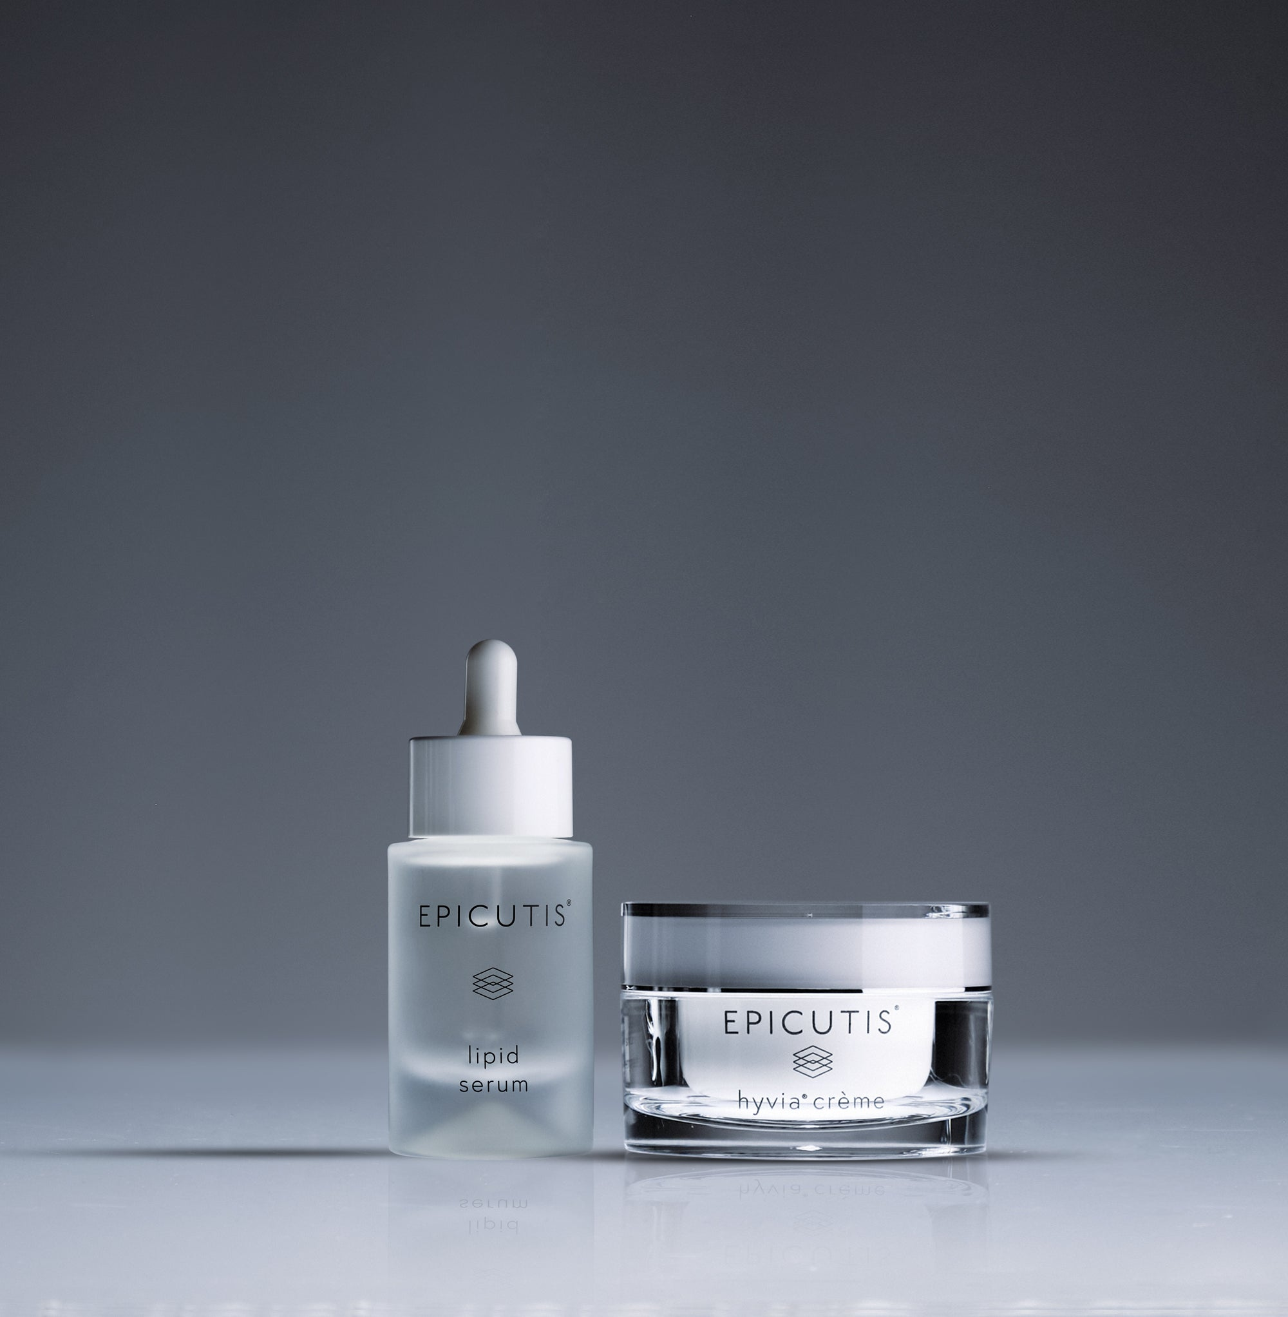
Brand and category EPICUTIS® | The Elixir Vanity > Skincare Sets
Retail price and size $395.00 USD | 1 + 1.7 oz
Contents and specifications Lipid Serum 1 oz and Hyvia® Crème 1.7 oz.

Website description
Pair targeted hydration with a rich finishing crème. This two-piece set brings together Lipid Serum and Hyvia® Crème for a simple routine that leaves skin feeling soft, comfortable, and moisturized.
Benefits and concerns Hydration; visible redness; dry or sensitive-feeling skin.
Featured ingredients TSC, hyaluronic acid, HYVIA®, shea butter.
How to use Use Lipid Serum first, then Hyvia® Crème, morning and evening. Apply a pea-sized amount of each; extend to neck and chest.
Full ingredients See the full Lipid Serum and Hyvia® Crème ingredient lists in their individual entries.
Suggested URL /elixir-vanity/epicutis-luxury-skincare-set
SEO title Luxury Skincare Set | The Elixir Vanity
Meta description Shop Epicutis Luxury Skincare Set at The Elixir Vanity by Velaisance. Explore product benefits, ingredients, and directions.
Image and alt text epicutis-luxury-skincare-set.jpg | EPICUTIS Luxury Skincare Set product packaging.
Source https://epicutis.com/products/luxury-skincare-set | Reviewed October 31, 2026

Cleansing Essentials Set
Website SKU EV-EPI-CES-01
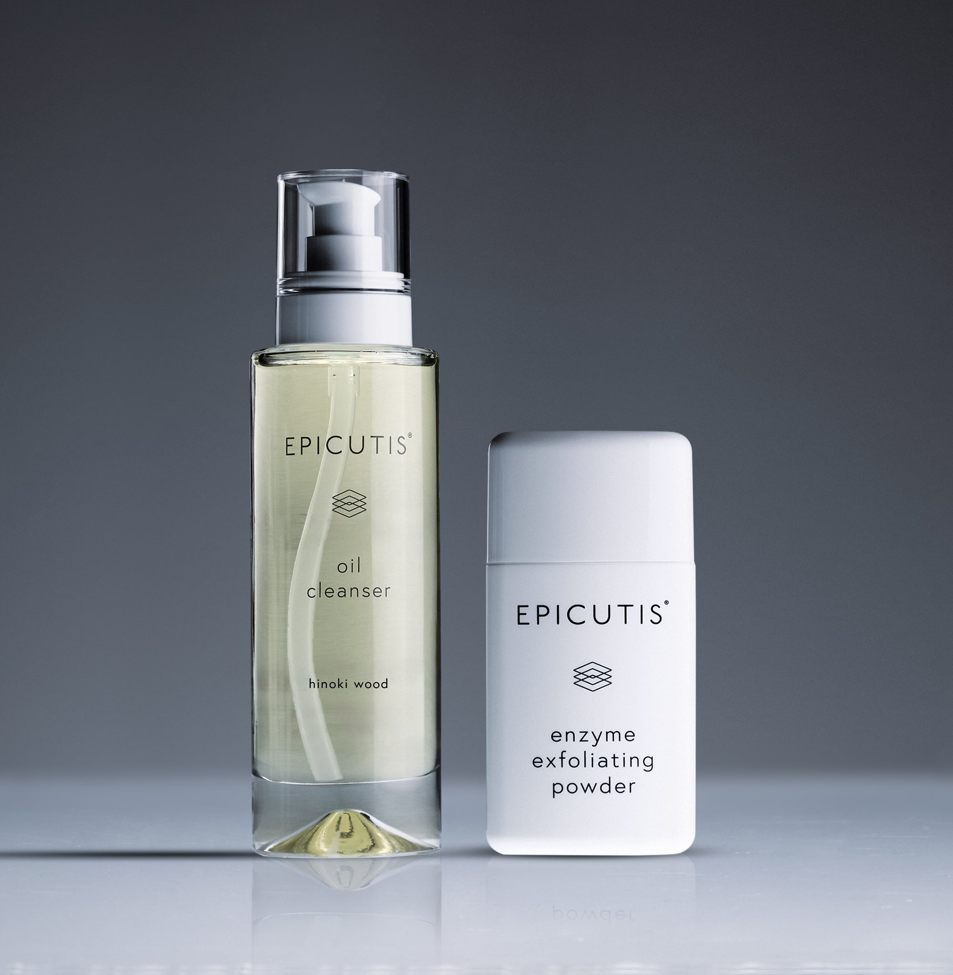
Brand and category EPICUTIS® | The Elixir Vanity > Cleansers and Sets
Retail price and size $105.00 USD | 3.38 oz + 1.1 oz
Contents and specifications Oil Cleanser 3.38 oz and Enzyme Exfoliating Powder 1.1 oz, as listed for this set.

Website description
Refresh your cleansing ritual with Oil Cleanser and Enzyme Exfoliating Powder. The oil removes makeup and daily buildup, while the powder provides occasional enzyme exfoliation for smoother-feeling skin.
Benefits and concerns Makeup removal; cleansing; uneven texture.
Featured ingredients Botanical oils, HYVIA®, protease, lipase.
How to use Massage 2–3 pumps of cleanser onto dry skin, add water, and rinse, morning and evening. At night 1–2 times weekly, mix a dime-sized amount of powder with cleanser; massage for one minute, add water for 30 seconds, then rinse. Avoid eyes.
Full ingredients Oil Cleanser: see its individual entry. Enzyme Exfoliating Powder: Sodium Lauroyl Glutamate, Synthetic Fluorphlogopite, Silica, Maltodextrin, Disodium Tetramethylhexadecenyl Succinoyl Cysteine, Protease, Lipase
Suggested URL /elixir-vanity/epicutis-cleansing-essentials-set
SEO title Cleansing Essentials Set | The Elixir Vanity
Meta description Shop Epicutis Cleansing Essentials Set at The Elixir Vanity by Velaisance. Explore product benefits, ingredients, and directions.
Image and alt text epicutis-cleansing-essentials-set.jpg | EPICUTIS Cleansing Essentials Set product packaging.
Source https://epicutis.com/products/cleansing-essentials-set | Reviewed October 31, 2026

Lipid Serum
Website SKU EV-EPI-LPS-01
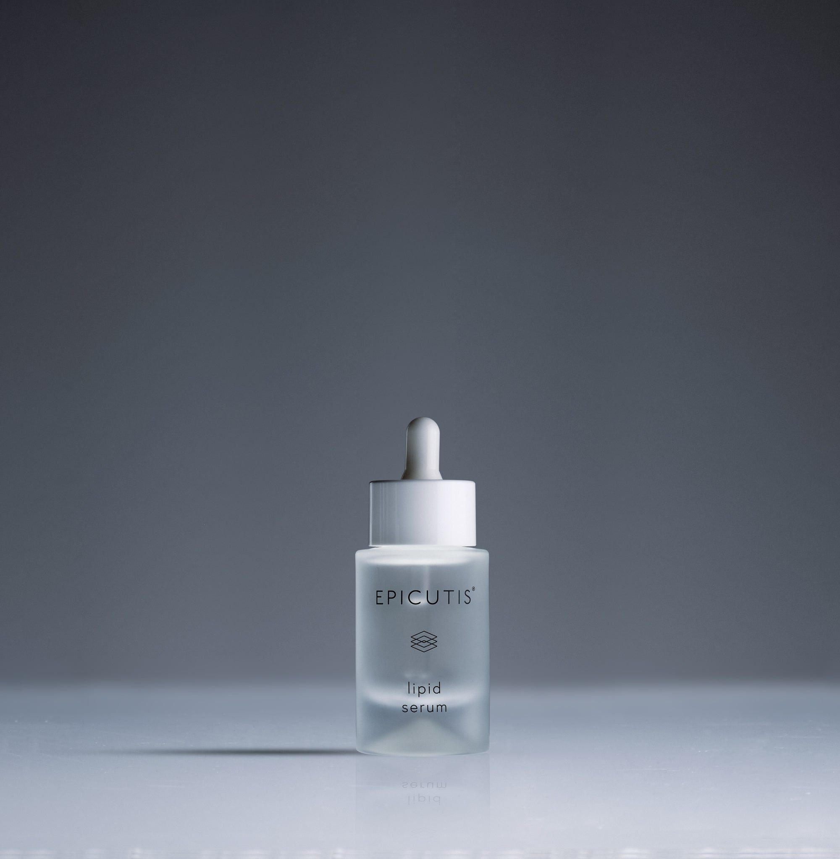
Brand and category EPICUTIS® | The Elixir Vanity > Serums
Retail price and size $250.00 USD | 1 oz

Website description
Give skin a comforting layer of hydration with this lightweight, eight-ingredient serum. TSC and hyaluronic acid help support a soft, moisturized complexion and improve the appearance of redness.
Benefits and concerns Dehydration; visible redness; sensitive-feeling skin.
Featured ingredients TSC, sodium hyaluronate, glycerin, propanediol.
How to use Morning and evening, smooth a pea-sized amount over the face until absorbed. Use an extra drop for neck and chest.
Full ingredients Water, Propanediol, Pentylene Glycol, Glycerin, Sodium Hyaluronate, Disodium Tetramethylhexadecenyl Succinoyl Cysteine, Sodium Phytate, Citric Acid
Suggested URL /elixir-vanity/epicutis-lipid-serum
SEO title Lipid Serum | The Elixir Vanity
Meta description Shop Epicutis Lipid Serum at The Elixir Vanity by Velaisance. Explore product benefits, ingredients, and directions.
Image and alt text epicutis-lipid-serum.jpg | EPICUTIS Lipid Serum product packaging.
Source https://epicutis.com/products/lipid-serum | Reviewed October 31, 2026

Hyvia® Crème
Website SKU EV-EPI-HYC-01
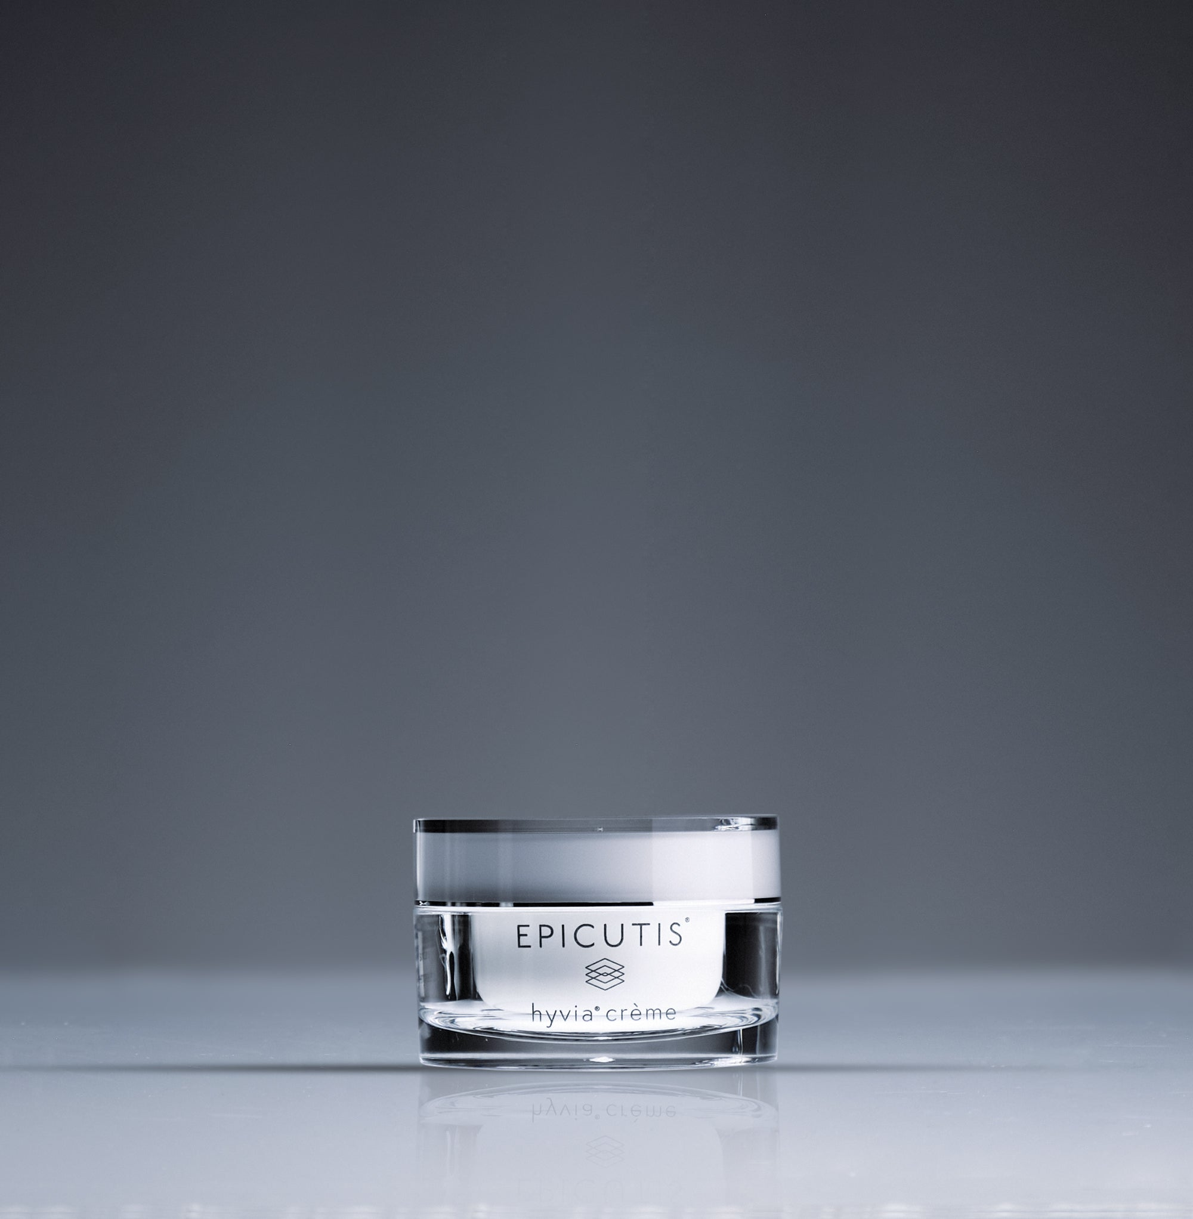
Brand and category EPICUTIS® | The Elixir Vanity > Moisturizers
Retail price and size $195.00 USD | 1.7 oz

Website description
Wrap skin in rich, velvety moisture. Hyvia® Crème combines chia-derived HYVIA® with conditioning botanicals and ceramide NP to leave skin looking dewy and feeling nourished.
Benefits and concerns Dryness; barrier support; dullness.
Featured ingredients HYVIA®, DSD, shea butter, evening primrose extract.
How to use Morning and evening, gently spread and press a pea-sized amount over face, neck, chest, and eye area until absorbed.
Full ingredients Water, Caprylic/ Capric Triglyceride, Propanediol, Glycerin, Butyrospermum Parkii (Shea) Butter, Pentylene Glycol, Limnanthes Alba Meadowfoam Seed Oil, Glyceryl Stearate SE, Stearyl Alcohol, Steareth-20, Tocopherol, Salvia Hispanica Seed Oil, DSD (Disodium S-Phytyl Diglycoloylcysteine), Spilanthes Acmella Flower Extract, Ceramide NP, Isocetyl Alcohol, Cetyl Alcohol, Phytosterols, Ferulic Acid, Oenothera Biennis (Evening Primrose) Seed Extract, Butylene Glycol, Carbomer, Sodium Phytate, Potassium Hydroxide
Suggested URL /elixir-vanity/epicutis-hyvia-creme
SEO title Hyvia® Crème | The Elixir Vanity
Meta description Shop Epicutis Hyvia® Crème at The Elixir Vanity by Velaisance. Explore product benefits, ingredients, and directions.
Image and alt text epicutis-hyvia-creme.jpg | EPICUTIS Hyvia® Crème product packaging.
Source https://epicutis.com/products/hyvia-creme | Reviewed October 31, 2026

Lipid Recovery Mask
Website SKU EV-EPI-LRF-01
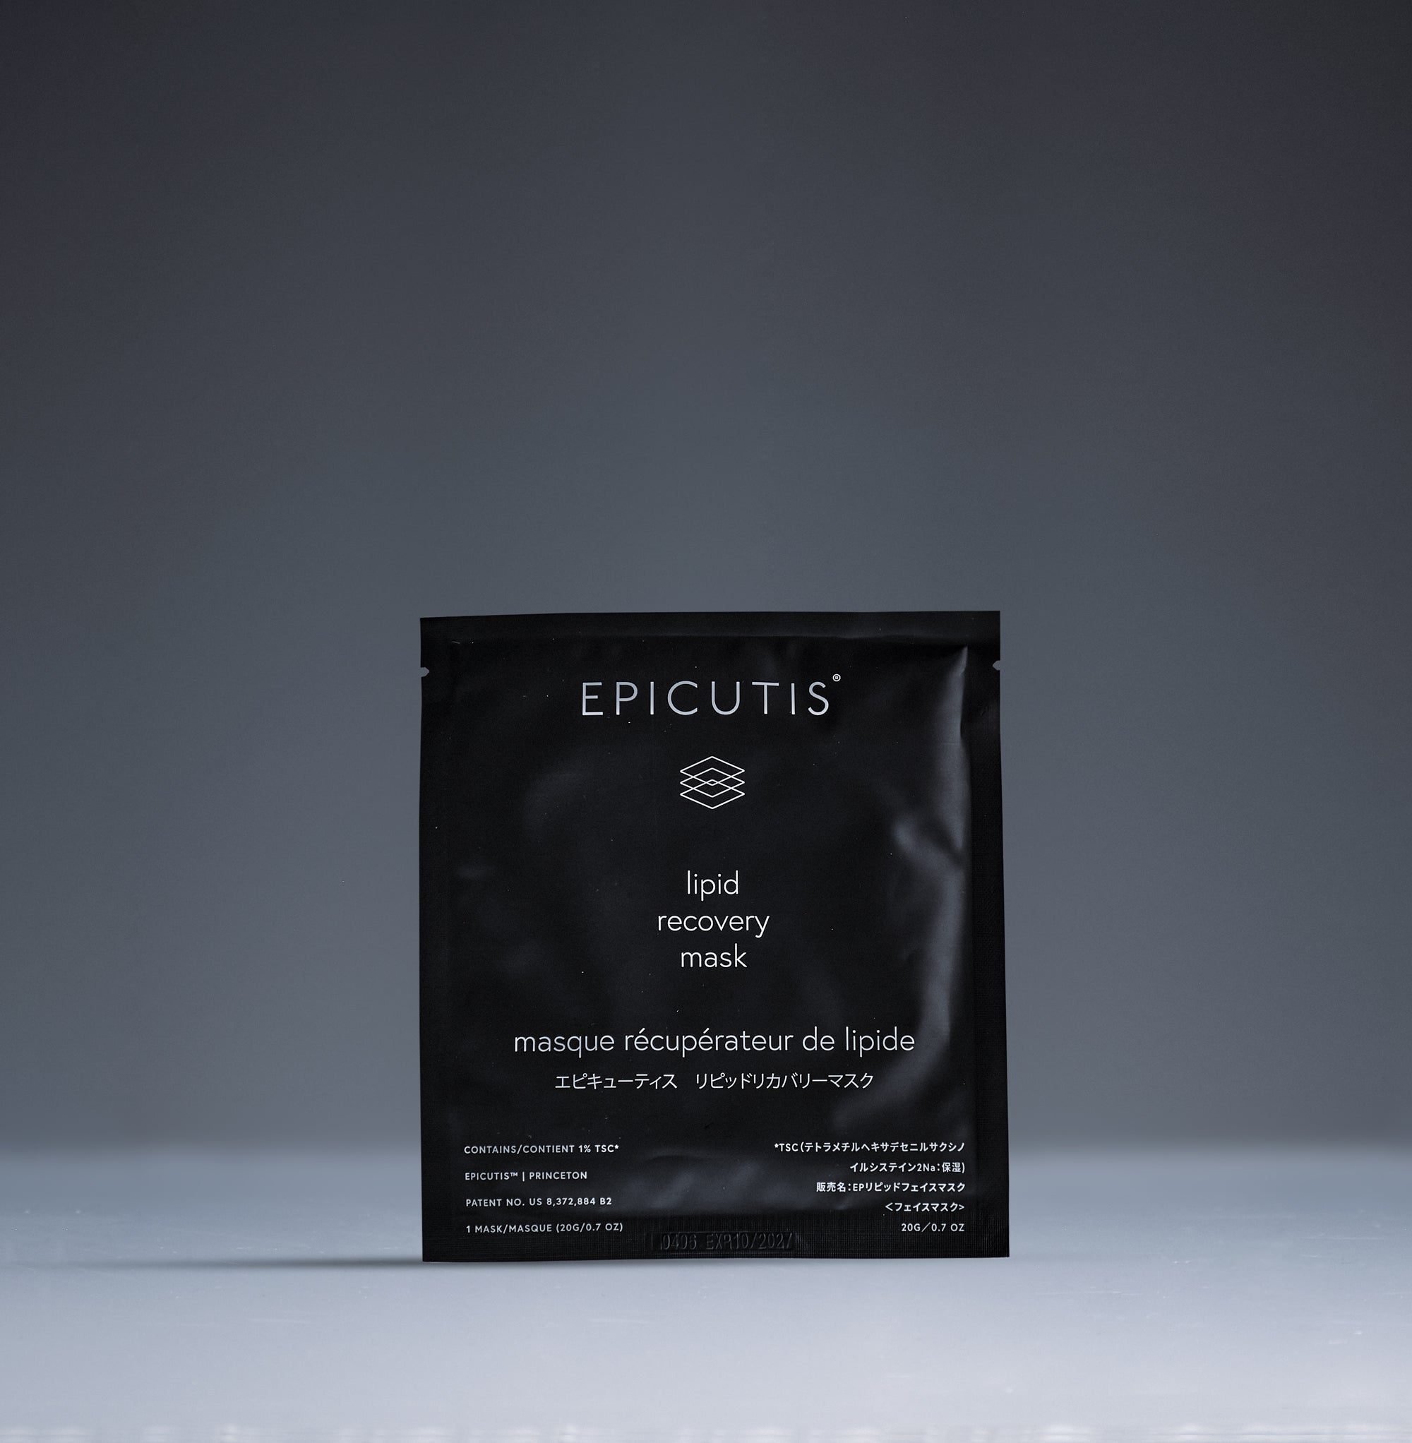
Brand and category EPICUTIS® | The Elixir Vanity > Masks
Retail price and size $125.00 USD | 0.7 oz per mask
Contents and specifications Five masks; 0.7 oz per mask.

Website description
Create a calming skincare pause with a serum-infused bio-cellulose face mask. The close-fitting material delivers hydration while helping skin feel soothed and look smoother.
Benefits and concerns Dehydration; visible redness; stressed-feeling skin.
Featured ingredients TSC, sodium hyaluronate, glycerin.
How to use Remove the white backing, position on face, then remove the blue layer. Smooth into place for 15 minutes. Remove and press in remaining serum without rinsing; follow with moisturizer.
Full ingredients Water, Propanediol, Glycerin, Pentylene Glycol, Disodium Tetramethylhexadecenyl Succinoyl Cysteine, Sodium Hyaluronate, Zinc Gluconate, Hydrolyzed Sodium Hyaluronate, Sodium Phytate, Citric Acid
Suggested URL /elixir-vanity/epicutis-lipid-recovery-mask
SEO title Lipid Recovery Mask | The Elixir Vanity
Meta description Shop Epicutis Lipid Recovery Mask at The Elixir Vanity by Velaisance. Explore product benefits, ingredients, and directions.
Image and alt text epicutis-lipid-recovery-mask.jpg | EPICUTIS Lipid Recovery Mask product packaging.
Source https://epicutis.com/products/lipid-recovery-mask | Reviewed October 31, 2026

Luxury On-The-Go Care Set
Website SKU EV-EPI-OTG-01
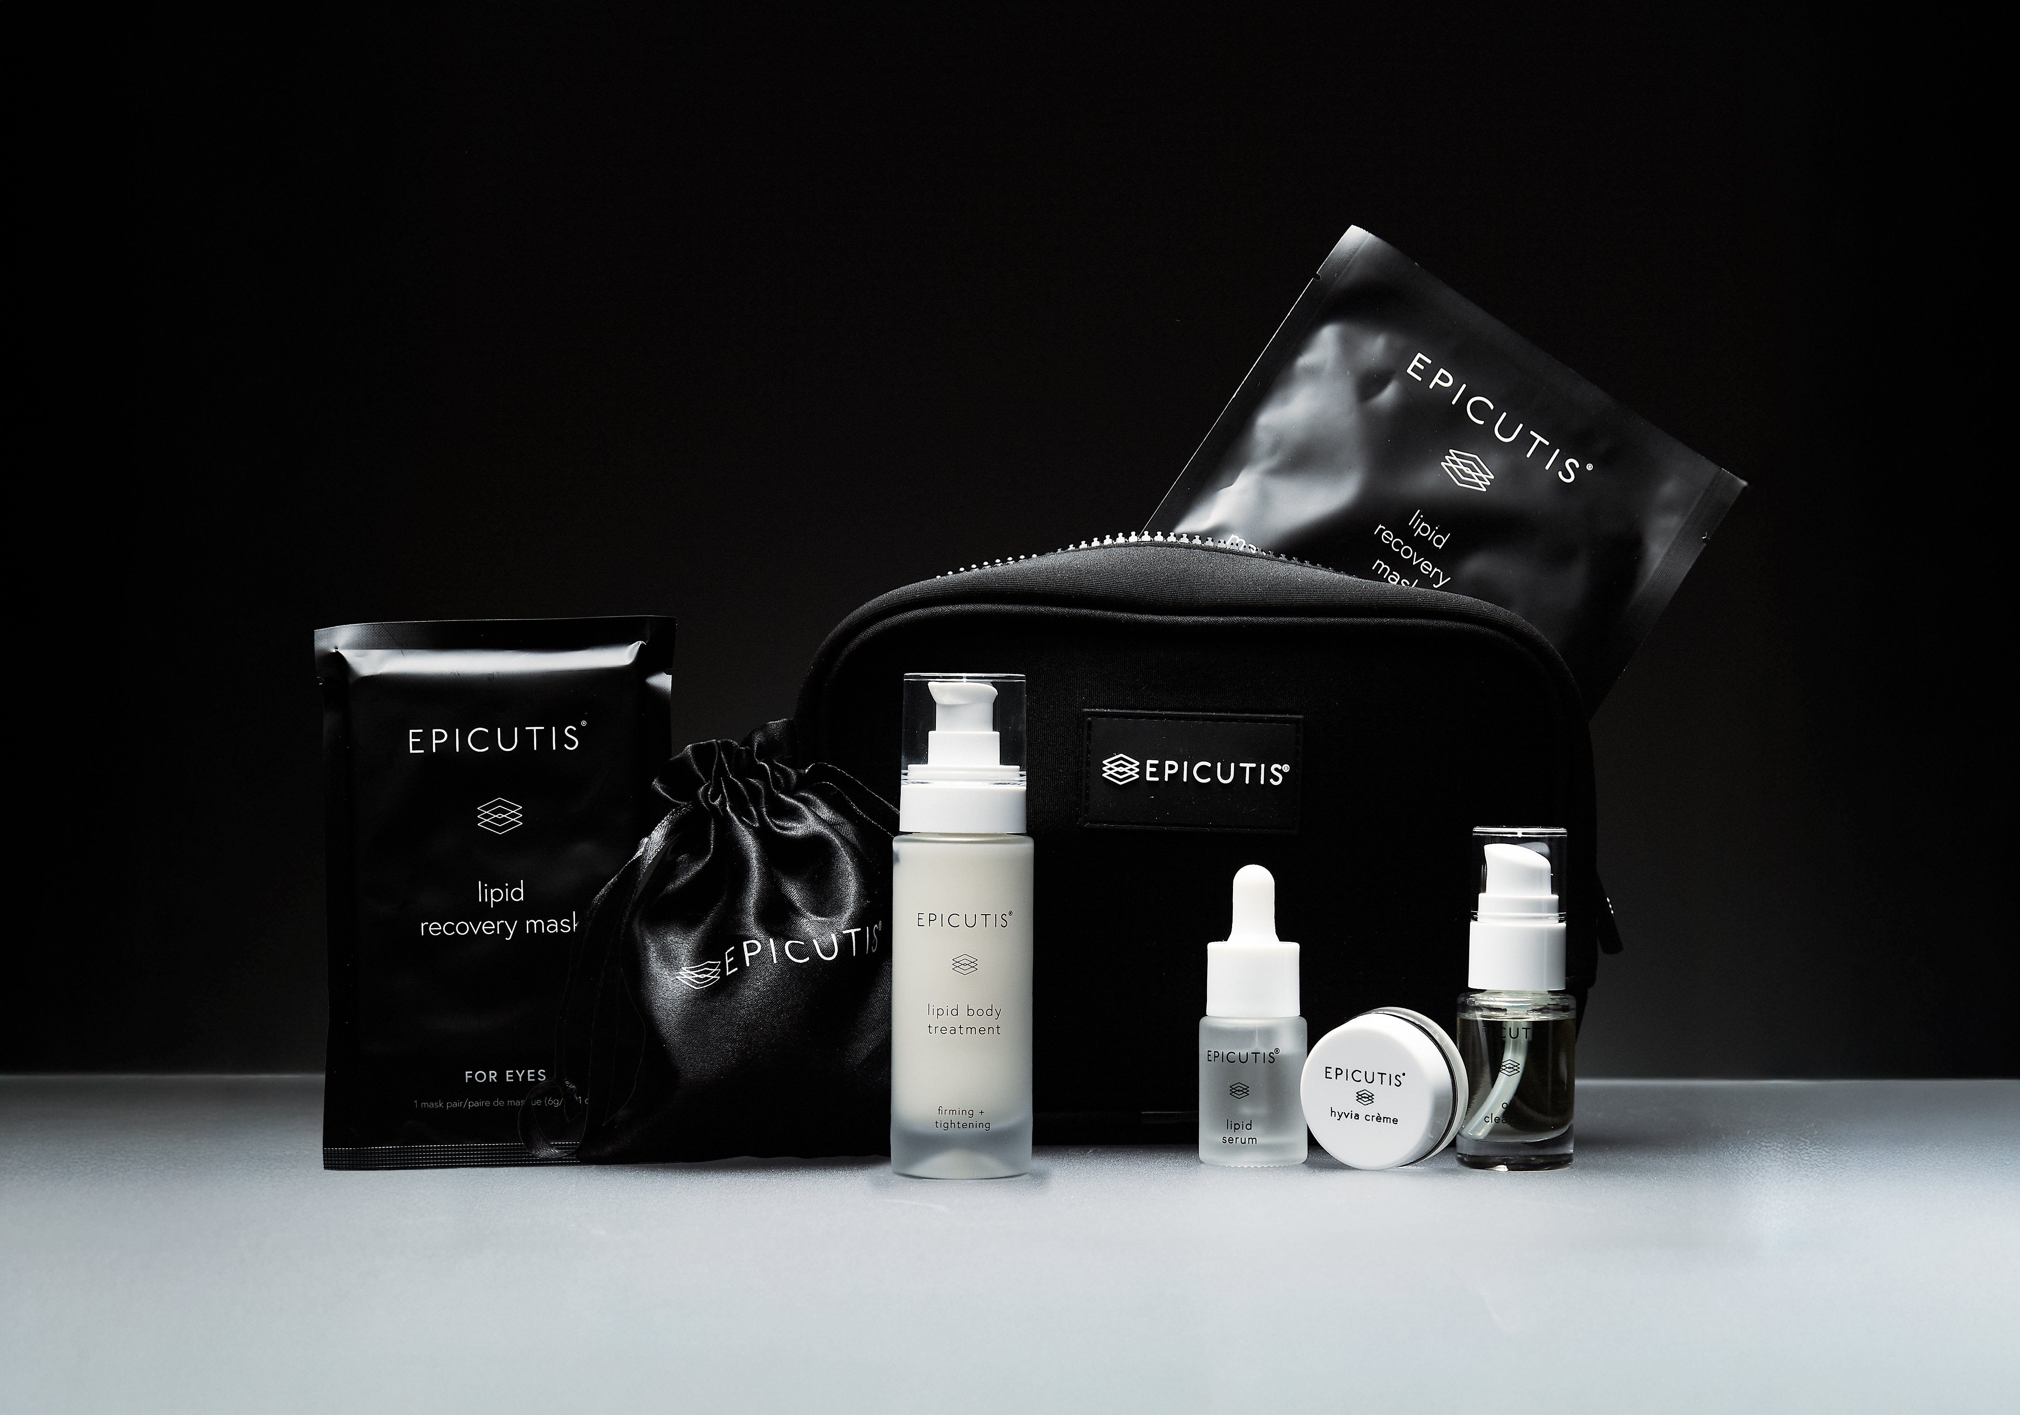
Brand and category EPICUTIS® | The Elixir Vanity > Travel and Skincare Sets
Retail price and size $175.00 USD | 5 ml + 10 ml + 15 ml
Contents and specifications Oil Cleanser, Lipid Serum, Hyvia® Crème, travel Lipid Body Treatment, and face and eye recovery masks. Confirm sizes and quantities before listing.

Website description
Take your Epicutis ritual with you. This portable assortment combines cleansing, serum, moisturizer, body care, and face and eye masks for convenient care away from home.
Benefits and concerns Travel; gifting; portable skincare routines.
Featured ingredients See the individual product listings for ingredient highlights.
How to use Cleanse, apply serum, then moisturize morning and evening. Follow the individual body treatment and mask directions included in this guide.
Full ingredients See individual entries for all six included products. The set page only supplies ingredient lists for Oil Cleanser, Lipid Serum, and Hyvia® Crème; verify the current travel products against packaging.
Suggested URL /elixir-vanity/epicutis-luxury-on-the-go
SEO title Luxury On-The-Go Care Set | The Elixir Vanity
Meta description Shop Epicutis Luxury On-The-Go Care Set at The Elixir Vanity by Velaisance. Explore product benefits, ingredients, and directions.
Image and alt text epicutis-luxury-on-the-go.jpg | EPICUTIS Luxury On-The-Go Care Set product packaging.
Source https://epicutis.com/products/luxury-on-the-go | Reviewed October 31, 2026

Oil Cleanser
Website SKU EV-EPI-OCL-01
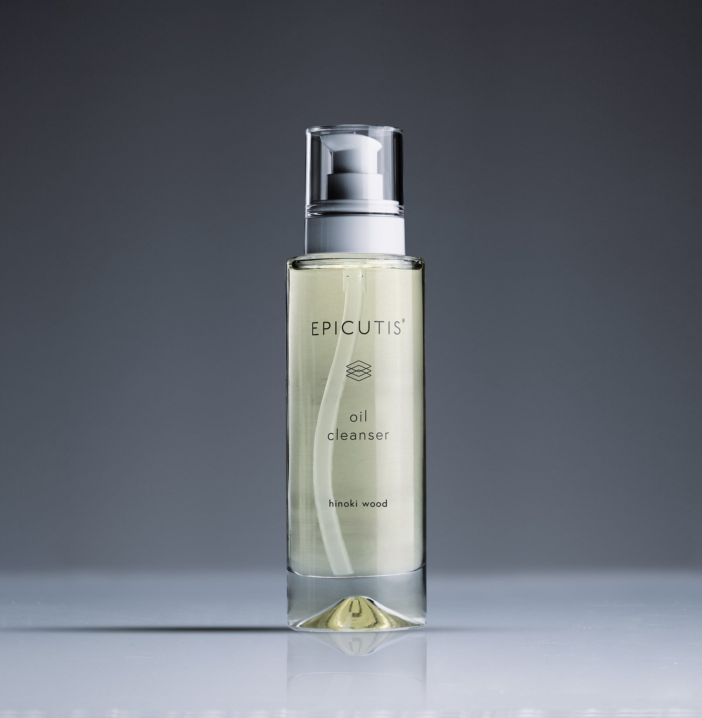
Brand and category EPICUTIS® | The Elixir Vanity > Cleansers
Retail price and size $85.00 USD | 4 oz

Website description
Melt away makeup, sunscreen, and daily buildup with a botanical oil cleanser that rinses away with water. Skin feels clean, soft, and comfortable after cleansing.
Benefits and concerns Daily cleansing; makeup and sunscreen removal.
Featured ingredients Sunflower, meadowfoam, macadamia, chia, and hinoki wood oils.
How to use Massage 2–3 pumps onto a dry face with dry hands. Add a little water to emulsify, then rinse thoroughly. Use morning and evening.
Full ingredients Helianthus Annuus (Sunflower) Seed Oil, Limnanthes Alba (Meadowfoam) Seed Oil, Polyglyceryl-2 Sesquioleate, Macadamia Integrifolia Seed Oil, Polyglyceryl-2 Caprate, Chamaecyparis Obtusa Wood Oil, Salvia Hispanica Seed Oil, Tocopherol, Oryza Sativa (Rice) Bran Oil
Suggested URL /elixir-vanity/epicutis-oil-cleanser
SEO title Oil Cleanser | The Elixir Vanity
Meta description Shop Epicutis Oil Cleanser at The Elixir Vanity by Velaisance. Explore product benefits, ingredients, and directions.
Image and alt text epicutis-oil-cleanser.jpg | EPICUTIS Oil Cleanser product packaging.
Source https://epicutis.com/products/oil-cleanser | Reviewed October 31, 2026

Lipid Body Treatment
Website SKU EV-EPI-LBT-01
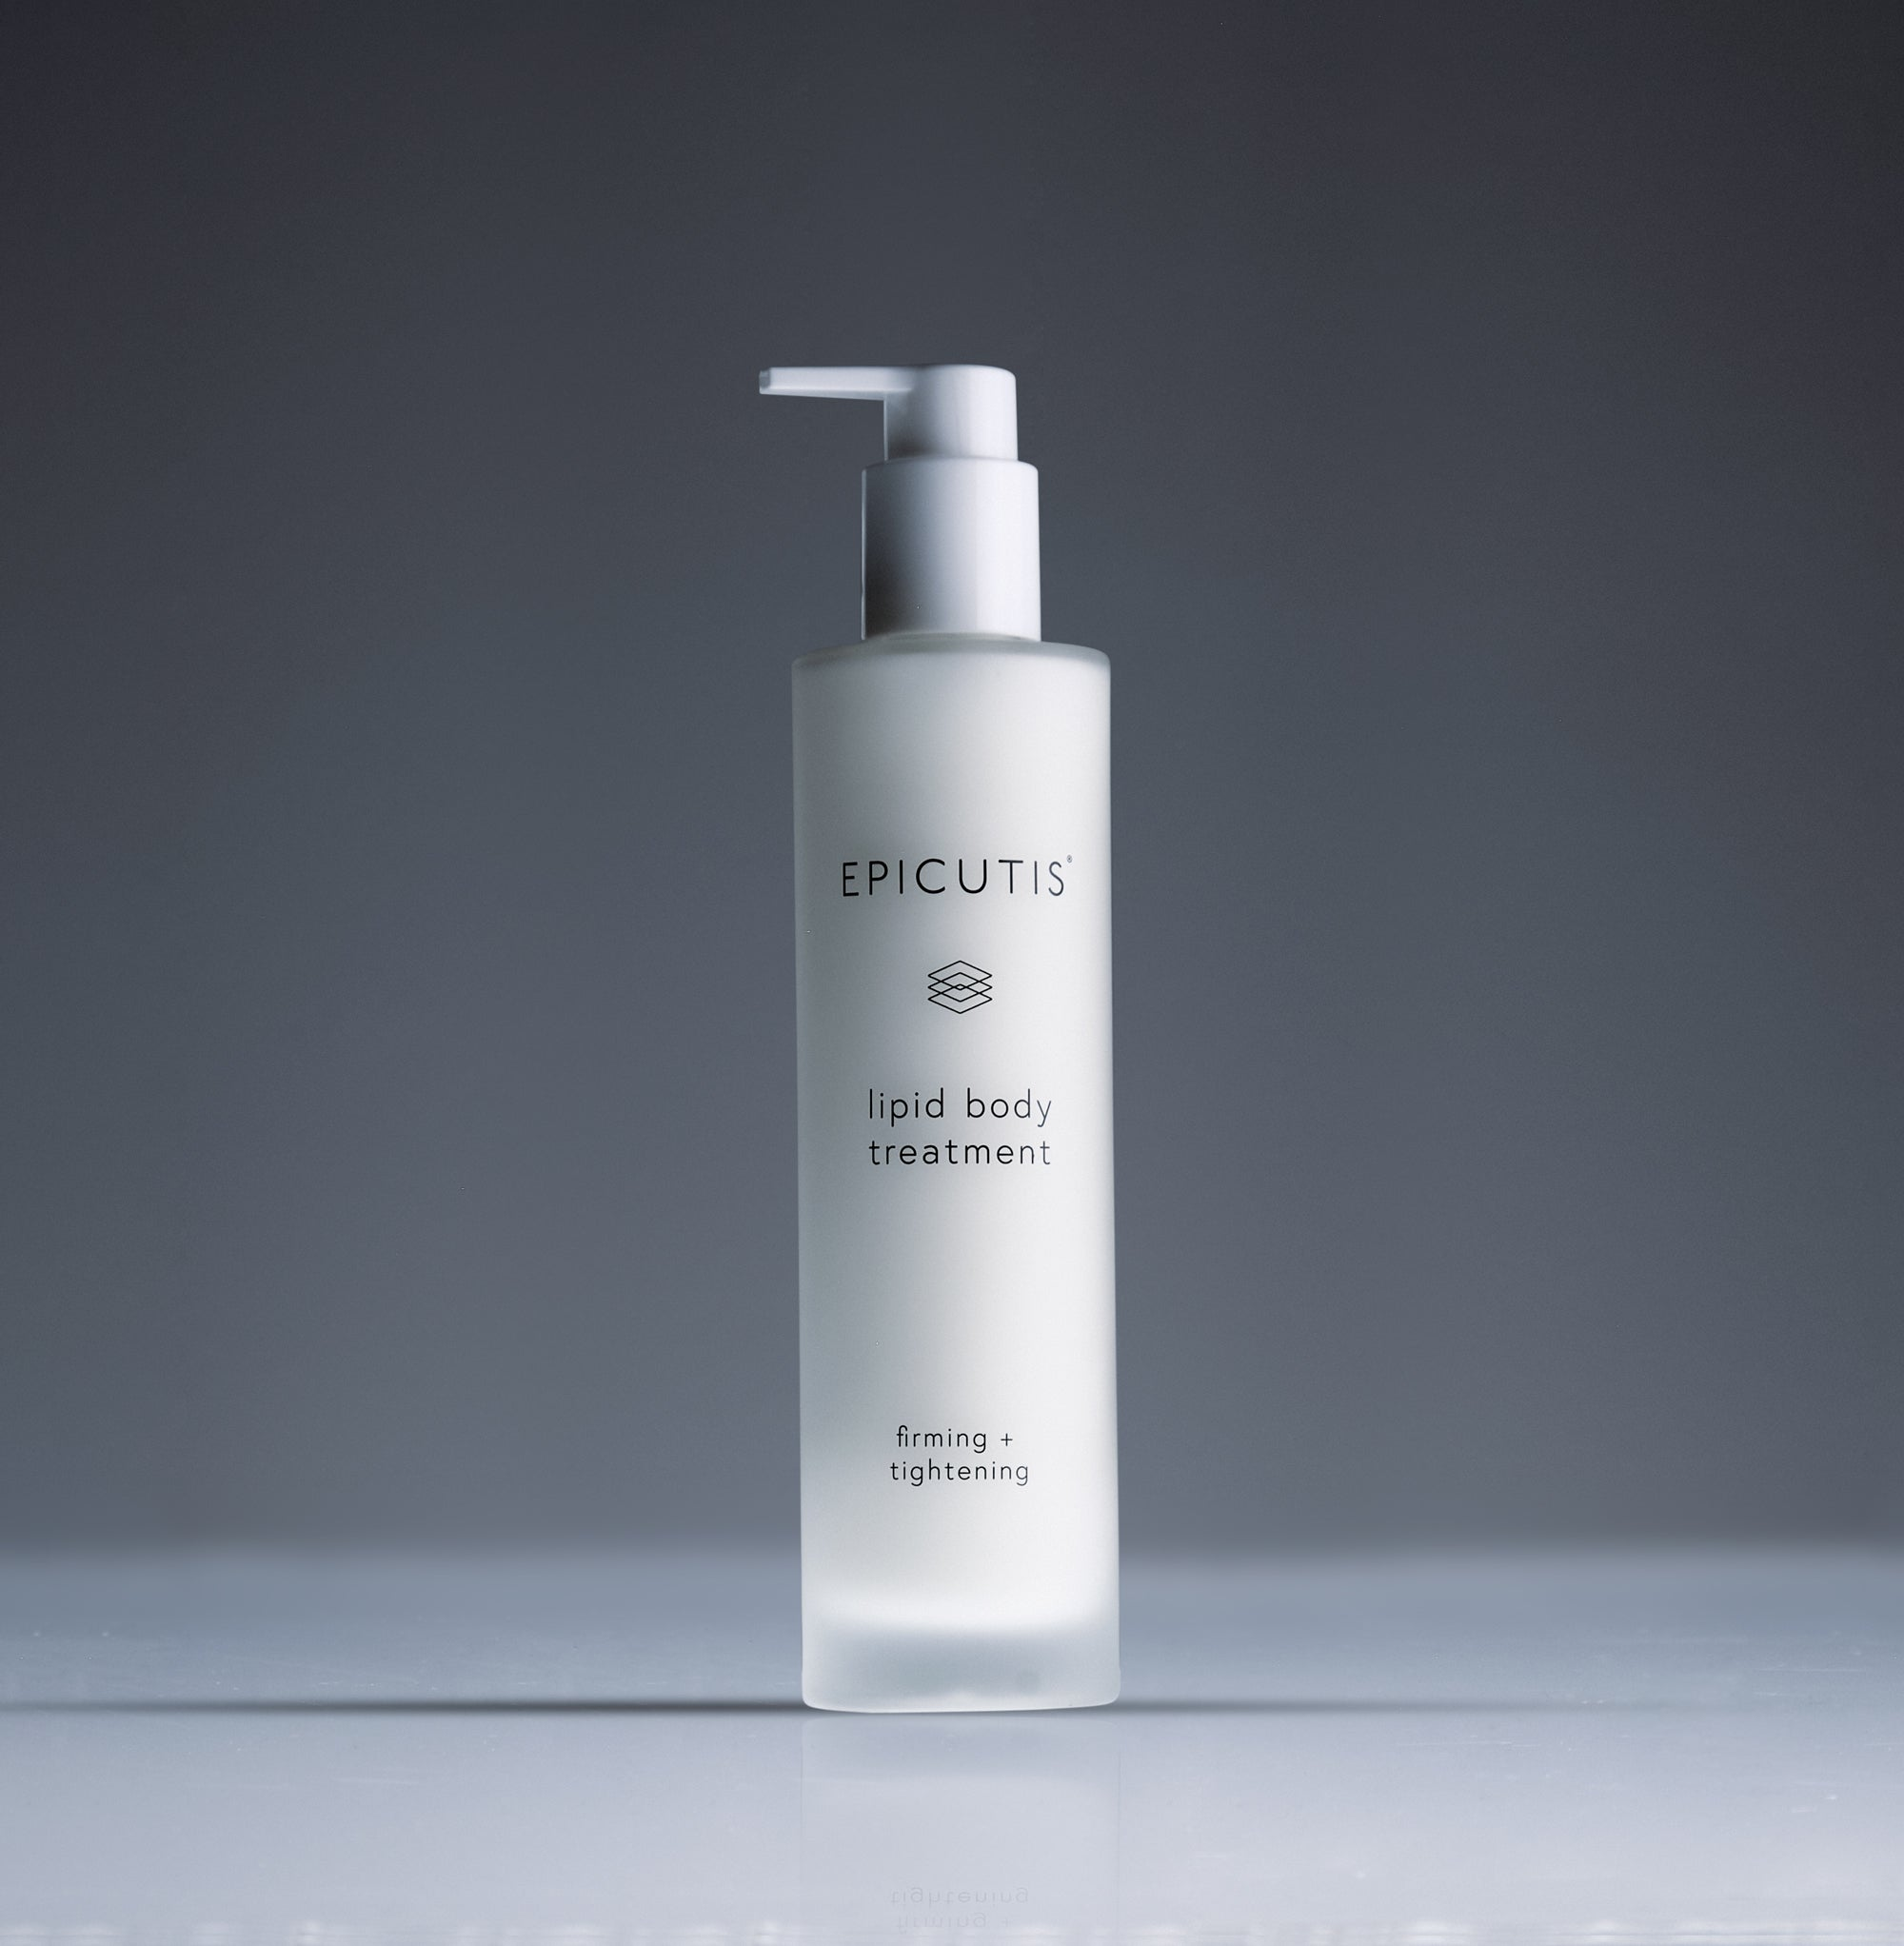
Brand and category EPICUTIS® | The Elixir Vanity > Body Care
Retail price and size $225.00 USD | 7.4 oz

Website description
Bring focused hydration to your body care ritual. This lightweight gel combines botanical extracts and moisture-binding ingredients to improve the look of loose, crepey skin and leave it feeling smoother.
Benefits and concerns Body dryness; crepey-looking skin; visible firmness.
Featured ingredients HYVIA®, Spilanthes acmella, seed extract, glucosyl hesperidin.
How to use Twice daily, massage 2–3 pumps over arms, torso, and legs. The brand also allows neck and chest use. Mild warmth may occur during initial applications.
Full ingredients Water, Propanediol, Caprylic/ Capric Triglyceride, Hydroxyethyl Urea, Pentylene Glycol, Glycerin, Ammonium Acryloyldimethyltaurate/VP Copolymer, Caffeine, Triethyl Citrate, Salvia Hispanica Seed Oil, Spilanthes Acmella Flower Extract, Sodium Hyaluronate, Nepheium Longana Seed Extract, Glucosyl Hesperidin, Tocopherol, Dihydroxylignoceroyl Phytosphingosine, Ceramide AP, Sodium Phytate, Citric Acid
Suggested URL /elixir-vanity/epicutis-lipid-body-treatment
SEO title Lipid Body Treatment | The Elixir Vanity
Meta description Shop Epicutis Lipid Body Treatment at The Elixir Vanity by Velaisance. Explore product benefits, ingredients, and directions.
Image and alt text epicutis-lipid-body-treatment.jpg | EPICUTIS Lipid Body Treatment product packaging.
Source https://epicutis.com/products/lipid-body-treatment | Reviewed October 31, 2026

Lipid Recovery Mask for Neck + Décolleté
Website SKU EV-EPI-LRN-01
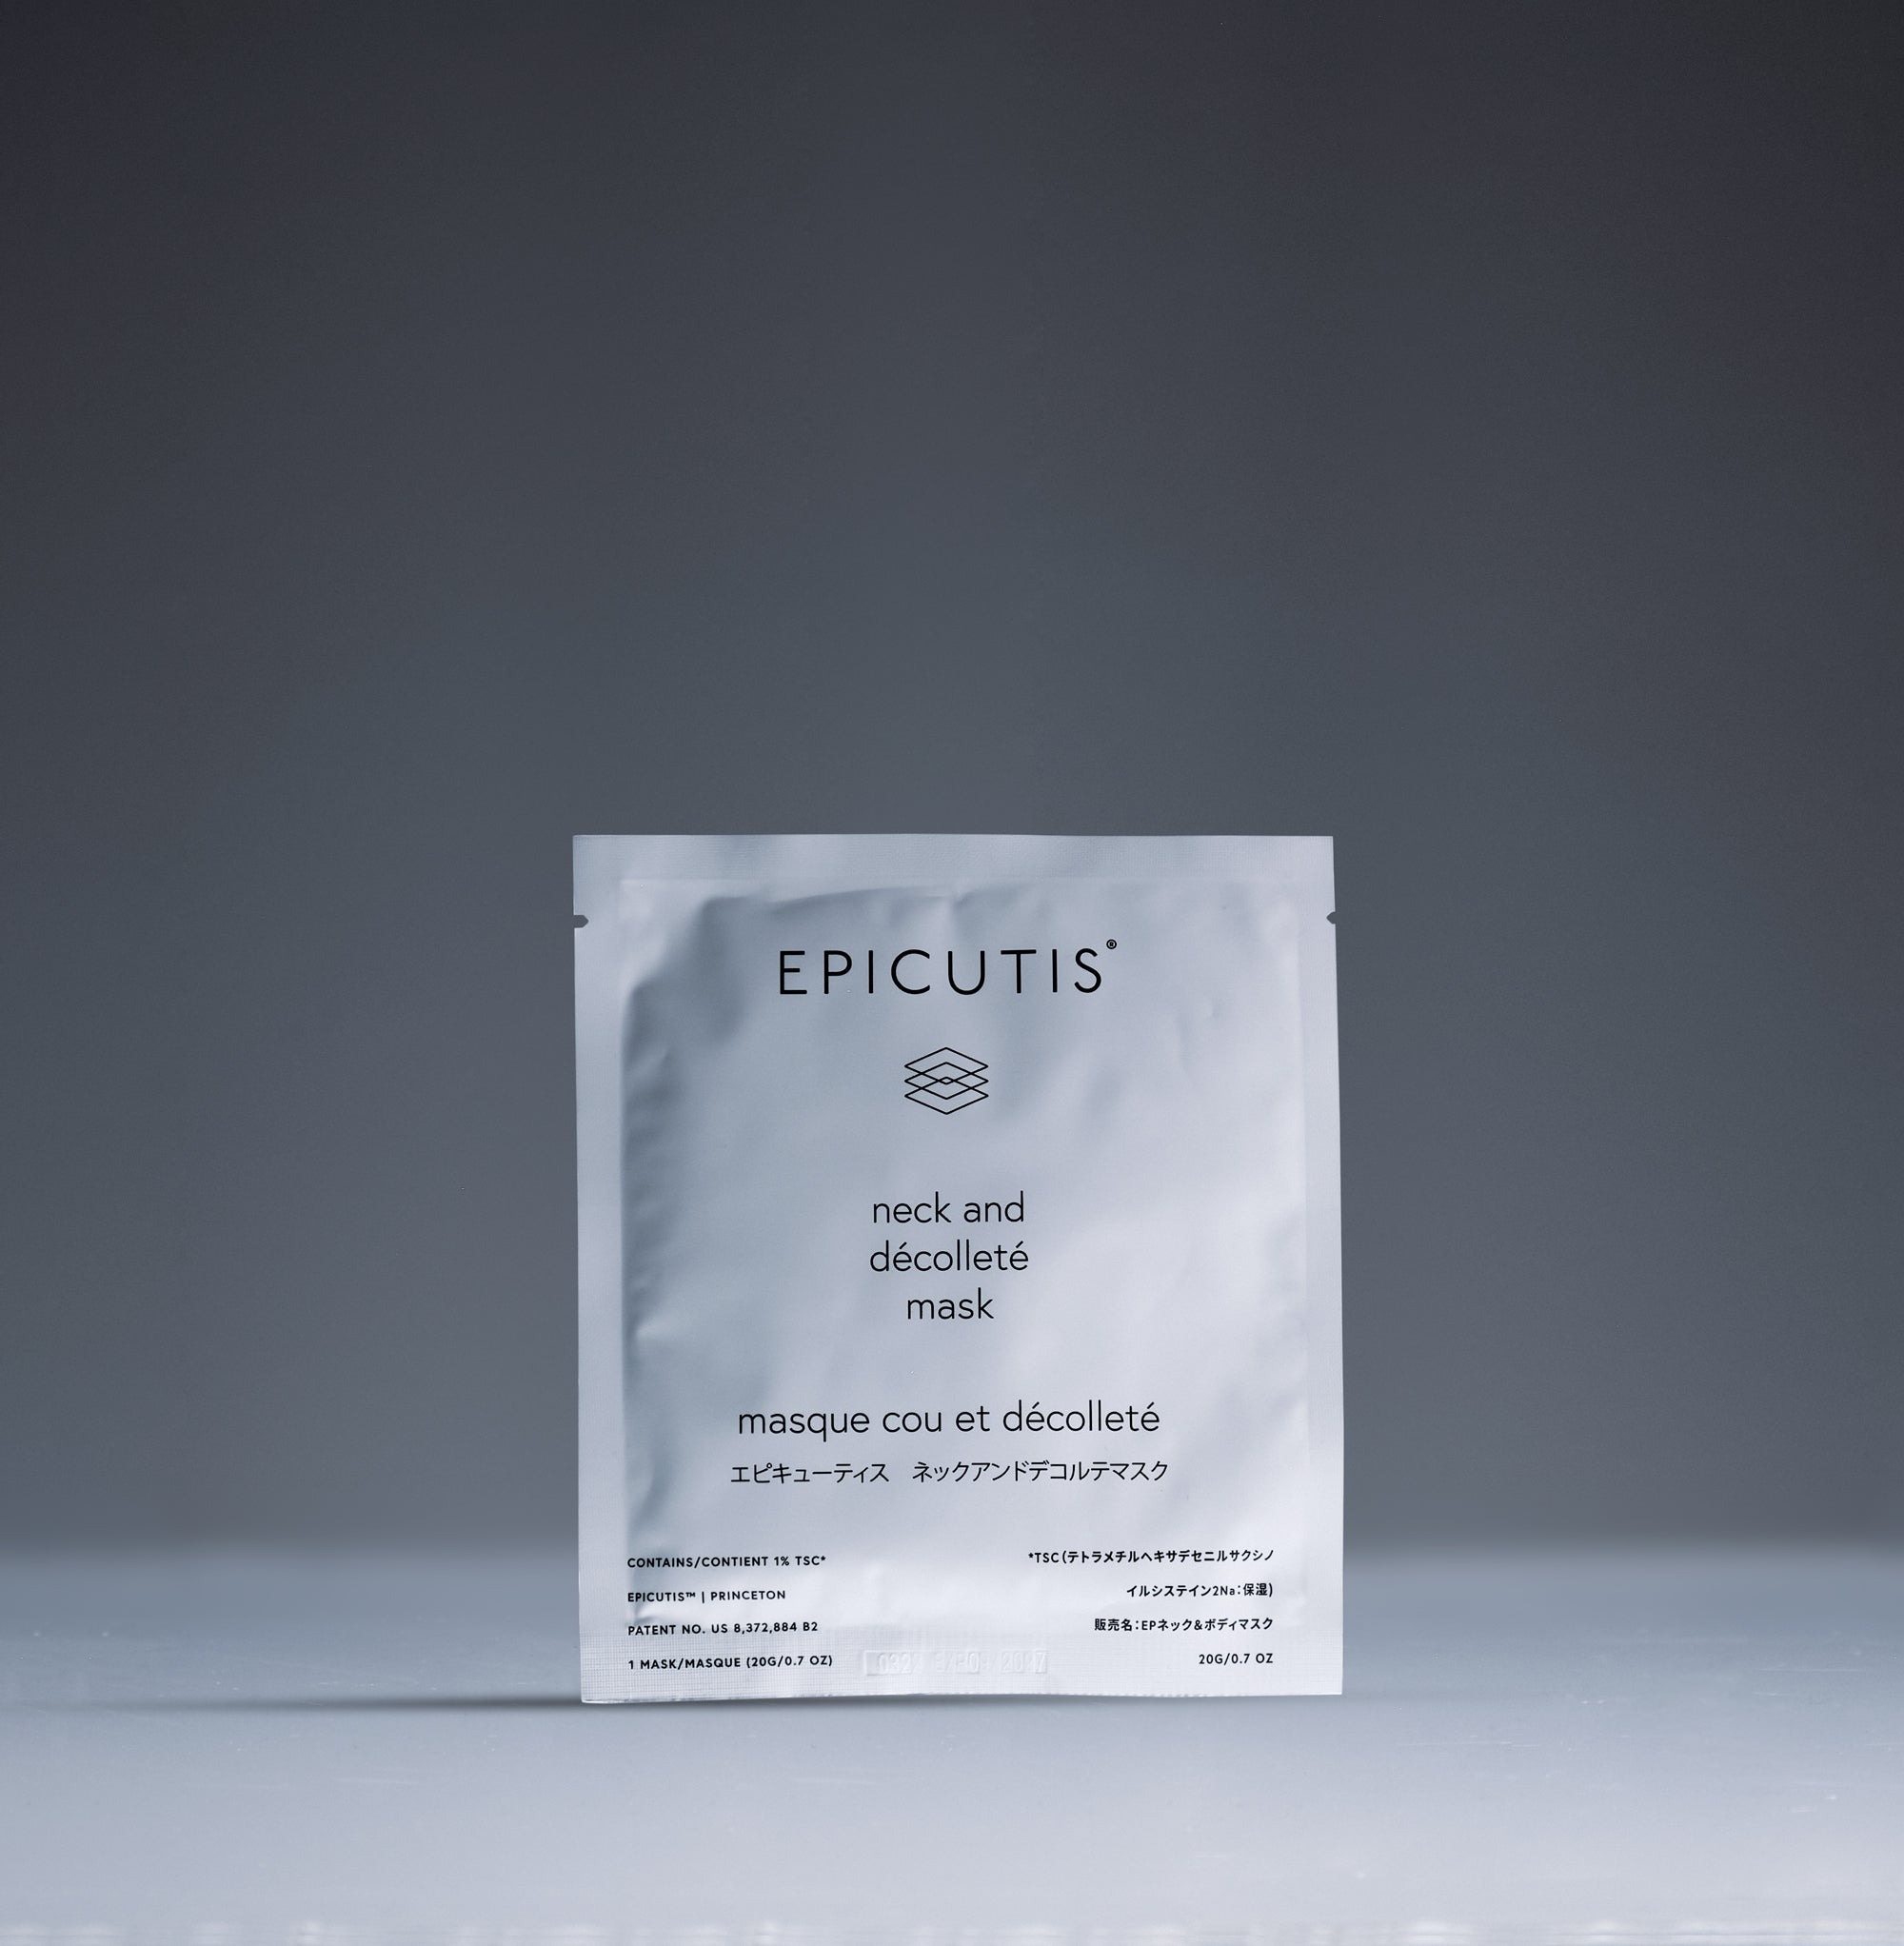
Brand and category EPICUTIS® | The Elixir Vanity > Masks
Retail price and size $140.00 USD | 0.7 oz per mask
Contents and specifications Five masks; 0.7 oz per mask.

Website description
Extend your skincare ritual below the face with a hydrating bio-cellulose mask designed for the neck and décolleté. It helps comfort stressed-feeling skin and soften the appearance of uneven texture.
Benefits and concerns Neck and chest hydration; visible redness; rough-looking texture.
Featured ingredients TSC, sodium hyaluronate, glycerin.
How to use Confirm neck-specific placement instructions with Epicutis before publishing. The current page repeats the face mask directions, including a 15-minute wear time and no rinse.
Full ingredients Water, Propanediol, Glycerin, Pentylene Glycol, Disodium Tetramethylhexadecenyl Succinoyl Cysteine, Sodium Hyaluronate, Zinc Gluconate, Hydrolyzed Sodium Hyaluronate, Sodium Phytate, Citric Acid
Suggested URL /elixir-vanity/epicutis-lipid-recovery-mask-for-neck-and-decollete
SEO title Lipid Recovery Mask for Neck + Décolleté | The Elixir Vanity
Meta description Shop Epicutis Lipid Recovery Mask for Neck + Décolleté at The Elixir Vanity by Velaisance. Explore product benefits, ingredients, and directions.
Image and alt text epicutis-lipid-recovery-mask-for-neck-and-decollete.jpg | EPICUTIS Lipid Recovery Mask for Neck + Décolleté product packaging.
Source https://epicutis.com/products/lipid-recovery-mask-for-neck-and-decollete | Reviewed October 31, 2026

Arctigenin Brightening Treatment
Website SKU EV-EPI-ABT-01
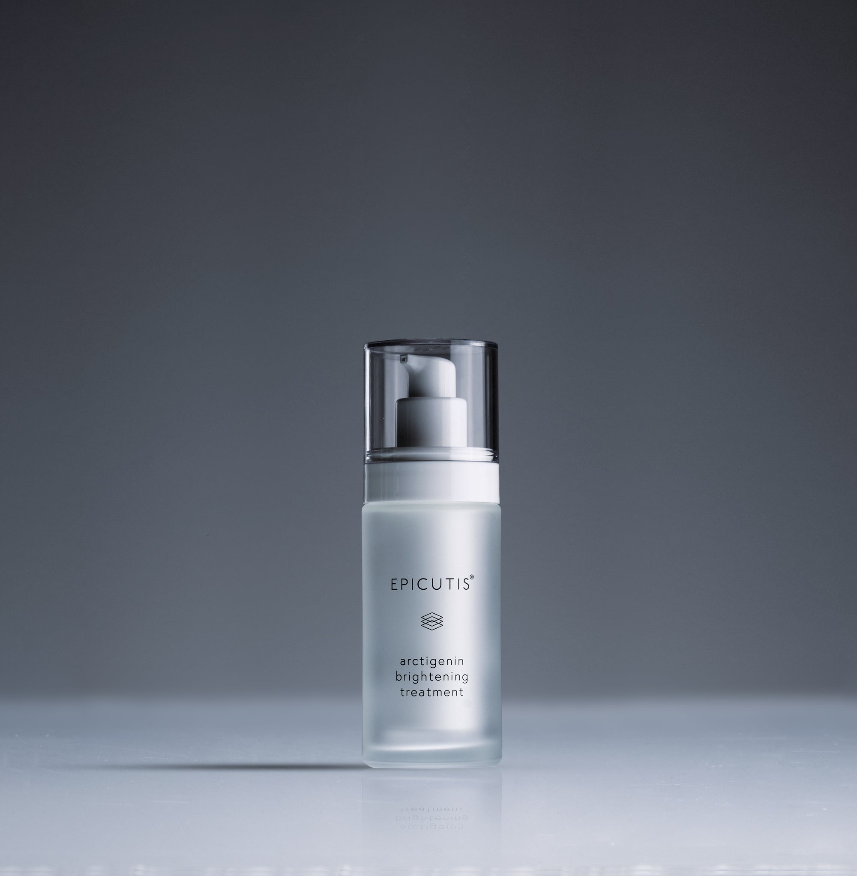
Brand and category EPICUTIS® | The Elixir Vanity > Brightening Treatments
Retail price and size $175.00 USD | 1 oz

Website description
Reveal a more luminous-looking complexion with this moisturizing treatment for uneven tone and dark spots. Burdock seed-derived ABSO, HYVIA®, and antioxidants support hydration and a brighter-looking finish.
Benefits and concerns Uneven tone; dark spots; dullness.
Featured ingredients ABSO, HYVIA®, DSD, ferulic acid.
How to use Morning and evening after Lipid Serum, spread a pea-sized amount over face, neck, chest, and targeted areas. Finish with Hyvia® Crème when additional moisture is desired.
Full ingredients Water, Squalane, Propanediol, Glycerin, Pentylene Glycol, Glyceryl Stearate SE, Arctium Lappa Seed Oil, Triethyl Citrate, Pinus Strobus Bark Extract, Salvia Hispanica Seed Oil, Disodium S-Phytyl Diglycoloylcysteine, Tocopherol, Ferulic Acid, Maltodextrin, Stearyl Alcohol, Steareth-20, Sodium Phytate, Carbomer, Potassium Hydroxide
Suggested URL /elixir-vanity/epicutis-arctigenin-brightening-treatment
SEO title Arctigenin Brightening Treatment | The Elixir Vanity
Meta description Shop Epicutis Arctigenin Brightening Treatment at The Elixir Vanity by Velaisance. Explore product benefits, ingredients, and directions.
Image and alt text epicutis-arctigenin-brightening-treatment.jpg | EPICUTIS Arctigenin Brightening Treatment product packaging.
Source https://epicutis.com/products/arctigenin-brightening-treatment | Reviewed October 31, 2026

Lipid Recovery Mask for Eyes
Website SKU EV-EPI-LRE-01
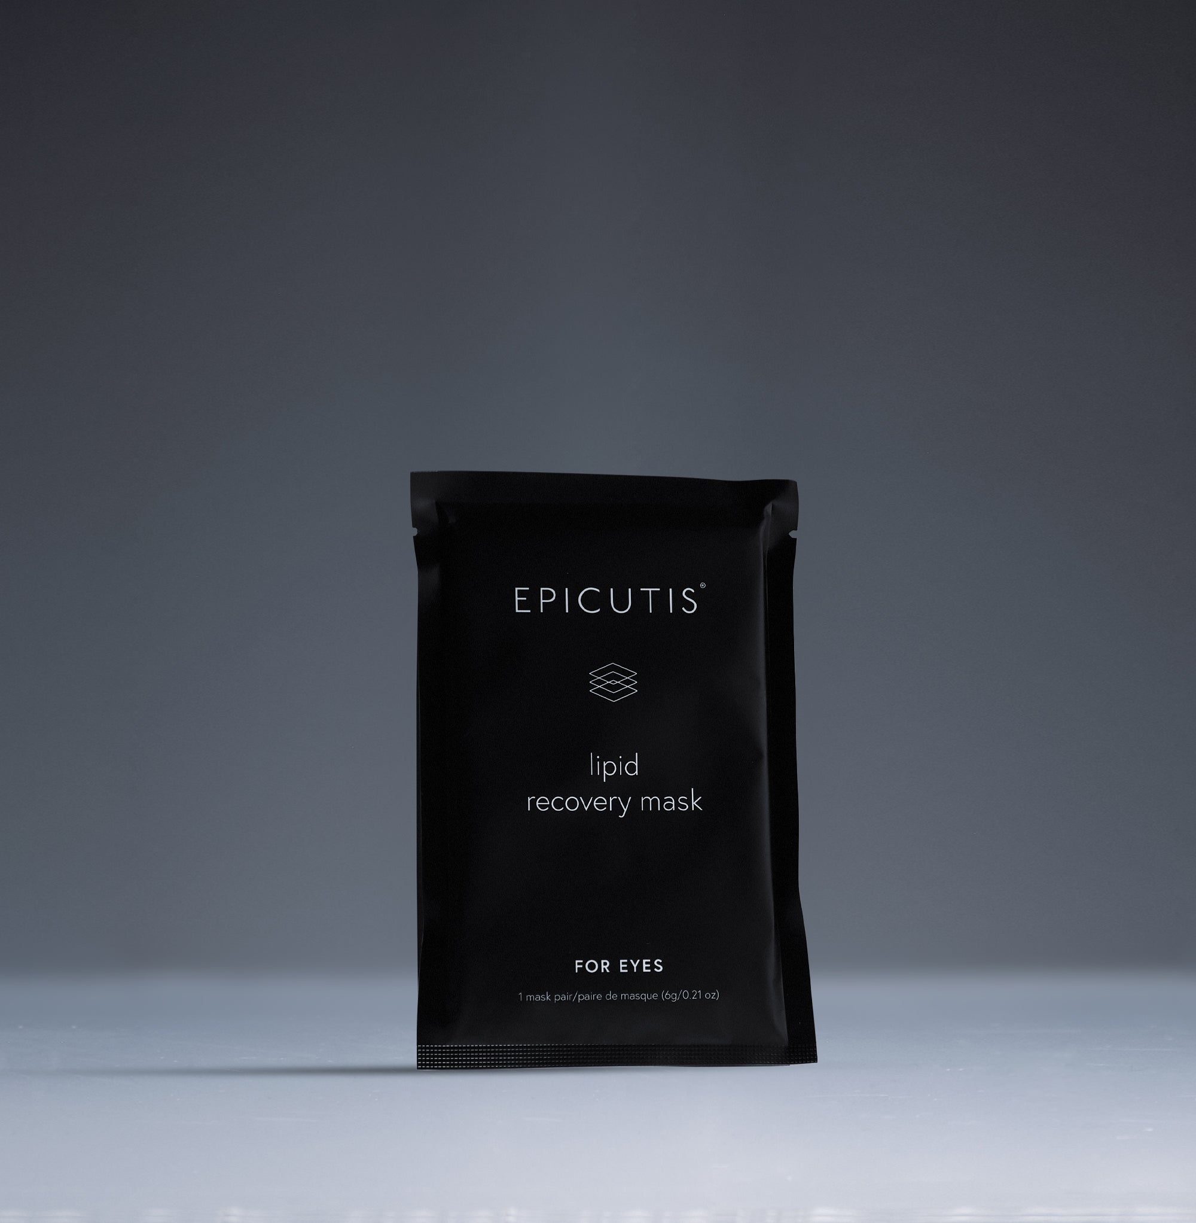
Brand and category EPICUTIS® | The Elixir Vanity > Eye Care and Masks
Retail price and size $105.00 USD | 0.21 oz
Contents and specifications Set of five as listed; page states 0.21 oz. Confirm whether weight is per pouch and that each pouch contains one pair.

Website description
Refresh the look of tired eyes with hydrating bio-cellulose patches. TSC, QFC, caffeine, and hyaluronic acid help improve the appearance of dark circles and puffiness while leaving the under-eye area feeling moisturized.
Benefits and concerns Dark-circle appearance; puffiness; under-eye dehydration.
Featured ingredients TSC, QFC, caffeine, hyaluronic acid.
How to use Remove the white mesh backing and place under eyes; remove the blue layer. Smooth into place for 10–15 minutes, then discard. Massage in remaining liquid without rinsing.
Full ingredients Water, Glycerin, Propanediol, Pentylene Glycol, Caffeine, Disodium Tetramethylhexadecenyl Succinoyl Cysteine, Acetylglutaminoyl Farnesylcysteine, Sodium Hyaluronate, Hydrolyzed Sodium Hyaluronate, PPG-13-Decyltetradeceth-24, Sodium Phytate, Citric Acid
Suggested URL /elixir-vanity/epicutis-lipid-recovery-mask-for-eyes
SEO title Lipid Recovery Mask for Eyes | The Elixir Vanity
Meta description Shop Epicutis Lipid Recovery Mask for Eyes at The Elixir Vanity by Velaisance. Explore product benefits, ingredients, and directions.
Image and alt text epicutis-lipid-recovery-mask-for-eyes.jpg | EPICUTIS Lipid Recovery Mask for Eyes product packaging.
Source https://epicutis.com/products/lipid-recovery-mask-for-eyes | Reviewed October 31, 2026

Hydrobiome Mist
Website SKU EV-EPI-HBM-01
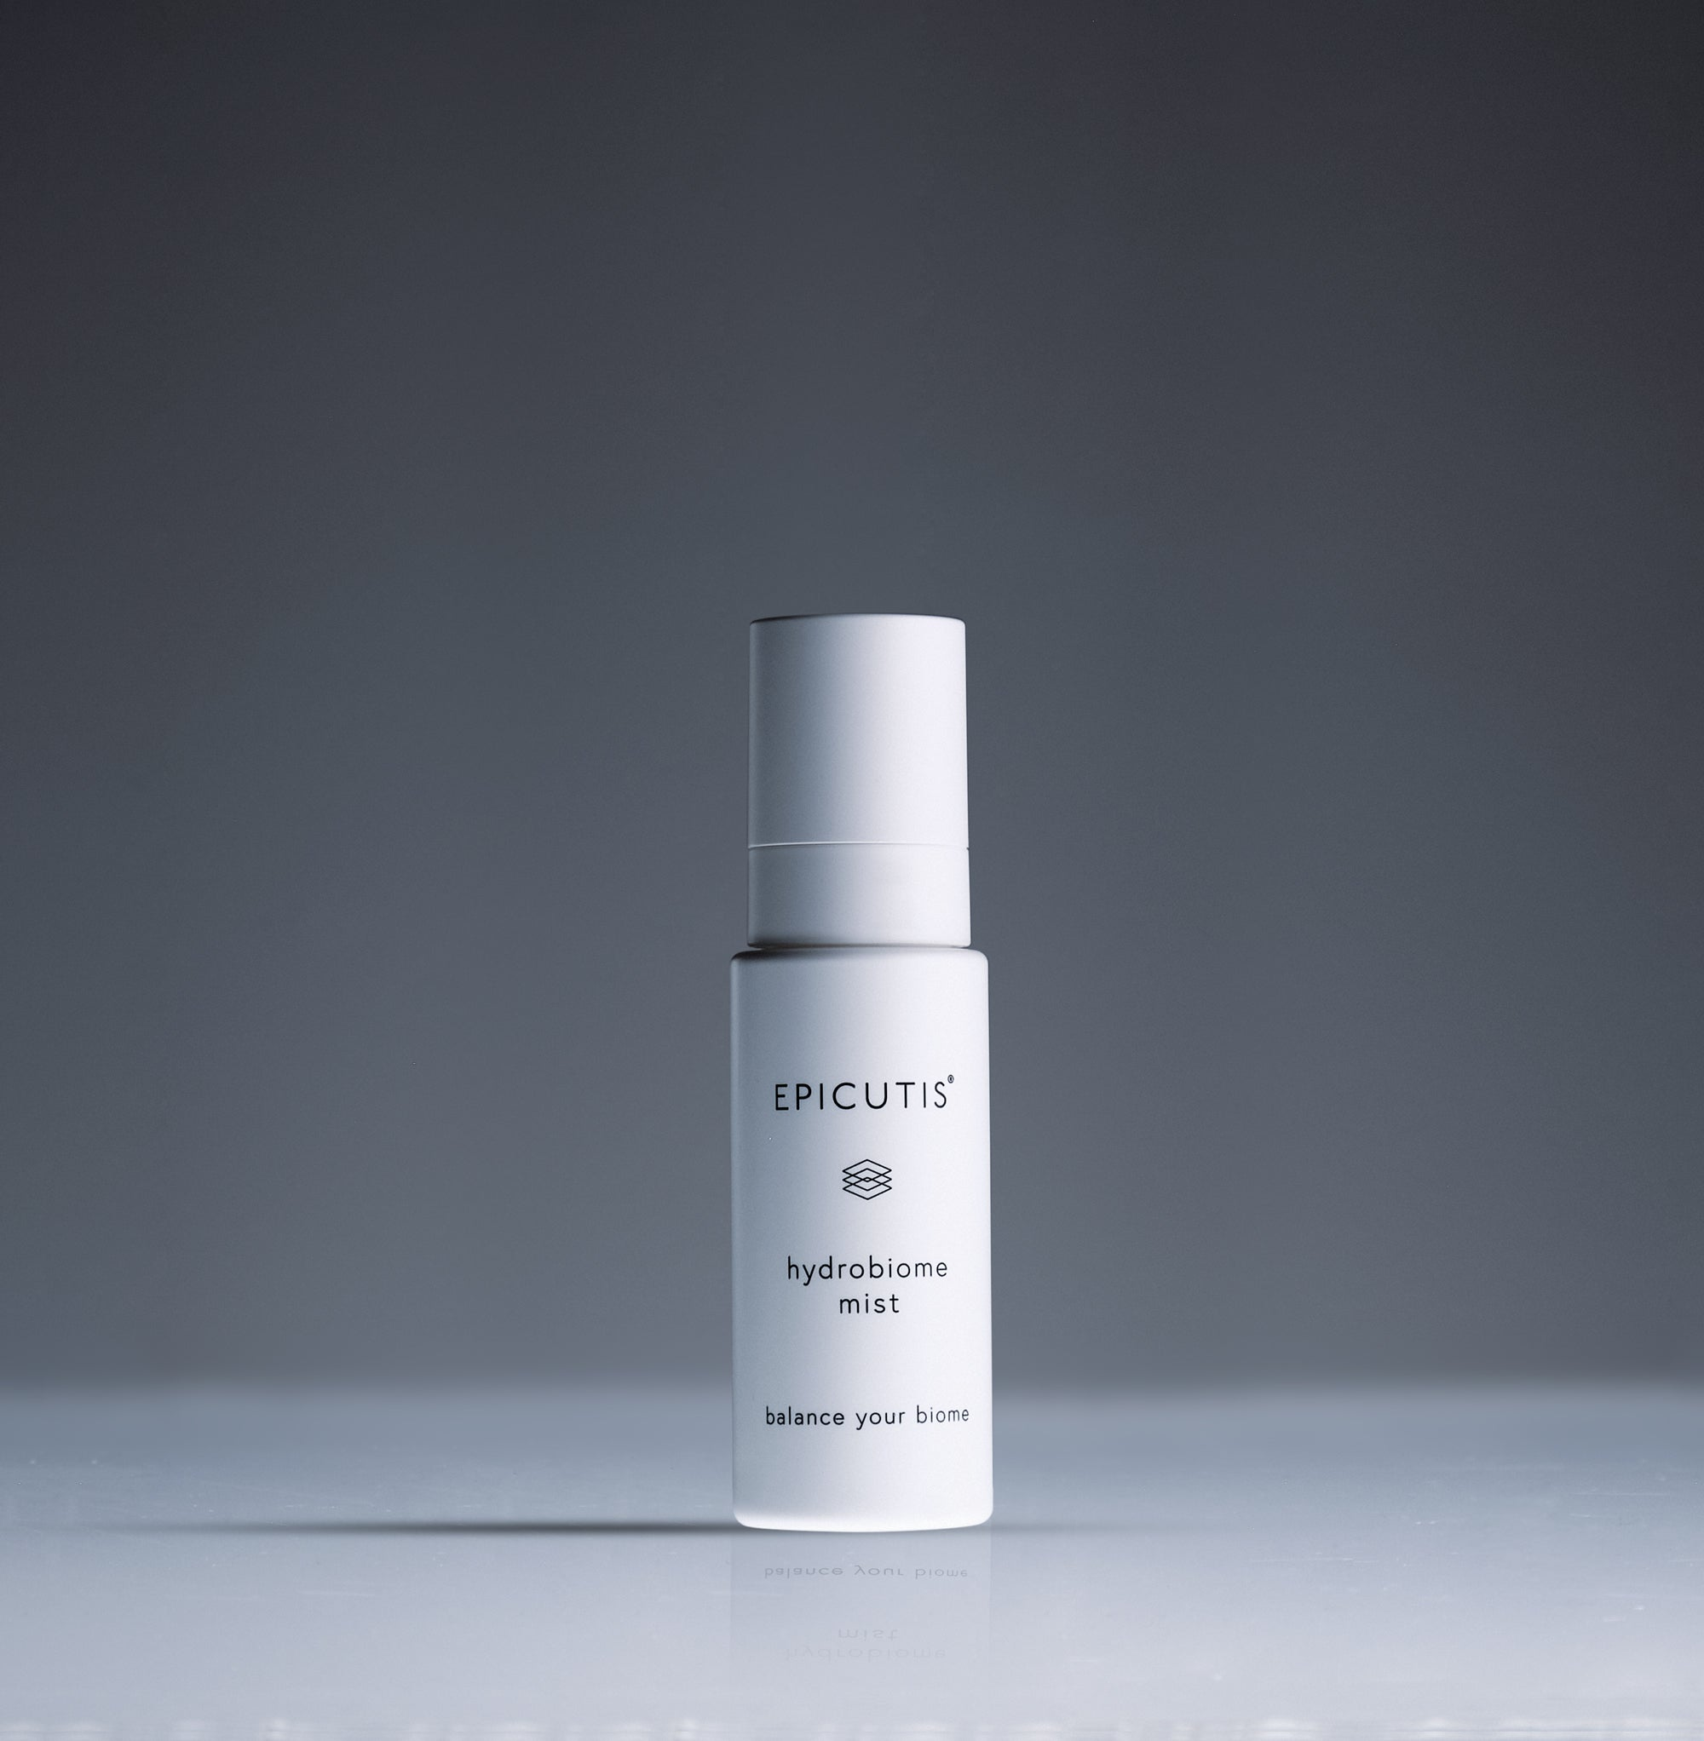
Brand and category EPICUTIS® | The Elixir Vanity > Mists
Retail price and size $75.00 USD | 1.7 oz

Website description
Refresh skin with a lightweight mist formulated with postbiotic and prebiotic ingredients. This hydrating blend supports a balanced-feeling complexion and gives skin a soothing boost throughout the day.
Benefits and concerns Dehydration; sensitive-feeling skin; microbiome support.
Featured ingredients Lactobacillus ferment, maltodextrin, grape seed extract, hinoki wood oil, glucosylrutin.
How to use Shake well. Mist face, neck, and chest with 2–3 sprays twice daily or as needed.
Full ingredients Aqua/Water/Eau, Propanediol, Pentylene Glycol, Glycerin, PPG-13-Decyltetradeceth-24, Chamaecyparis Obtusa Wood Oil, Vitis Vinifera (Grape) Seed Extract, Lactobacillus Ferment, Maltodextrin, Glucosylrutin, Sodium Phytate, Citric Acid
Suggested URL /elixir-vanity/epicutis-hydrobiome-mist
SEO title Hydrobiome Mist | The Elixir Vanity
Meta description Shop Epicutis Hydrobiome Mist at The Elixir Vanity by Velaisance. Explore product benefits, ingredients, and directions.
Image and alt text epicutis-hydrobiome-mist.jpg | EPICUTIS Hydrobiome Mist product packaging.
Source https://epicutis.com/products/hydrobiome-mist | Reviewed October 31, 2026

Lipid Shield SPF 30
Website SKU EV-EPI-SPF-01
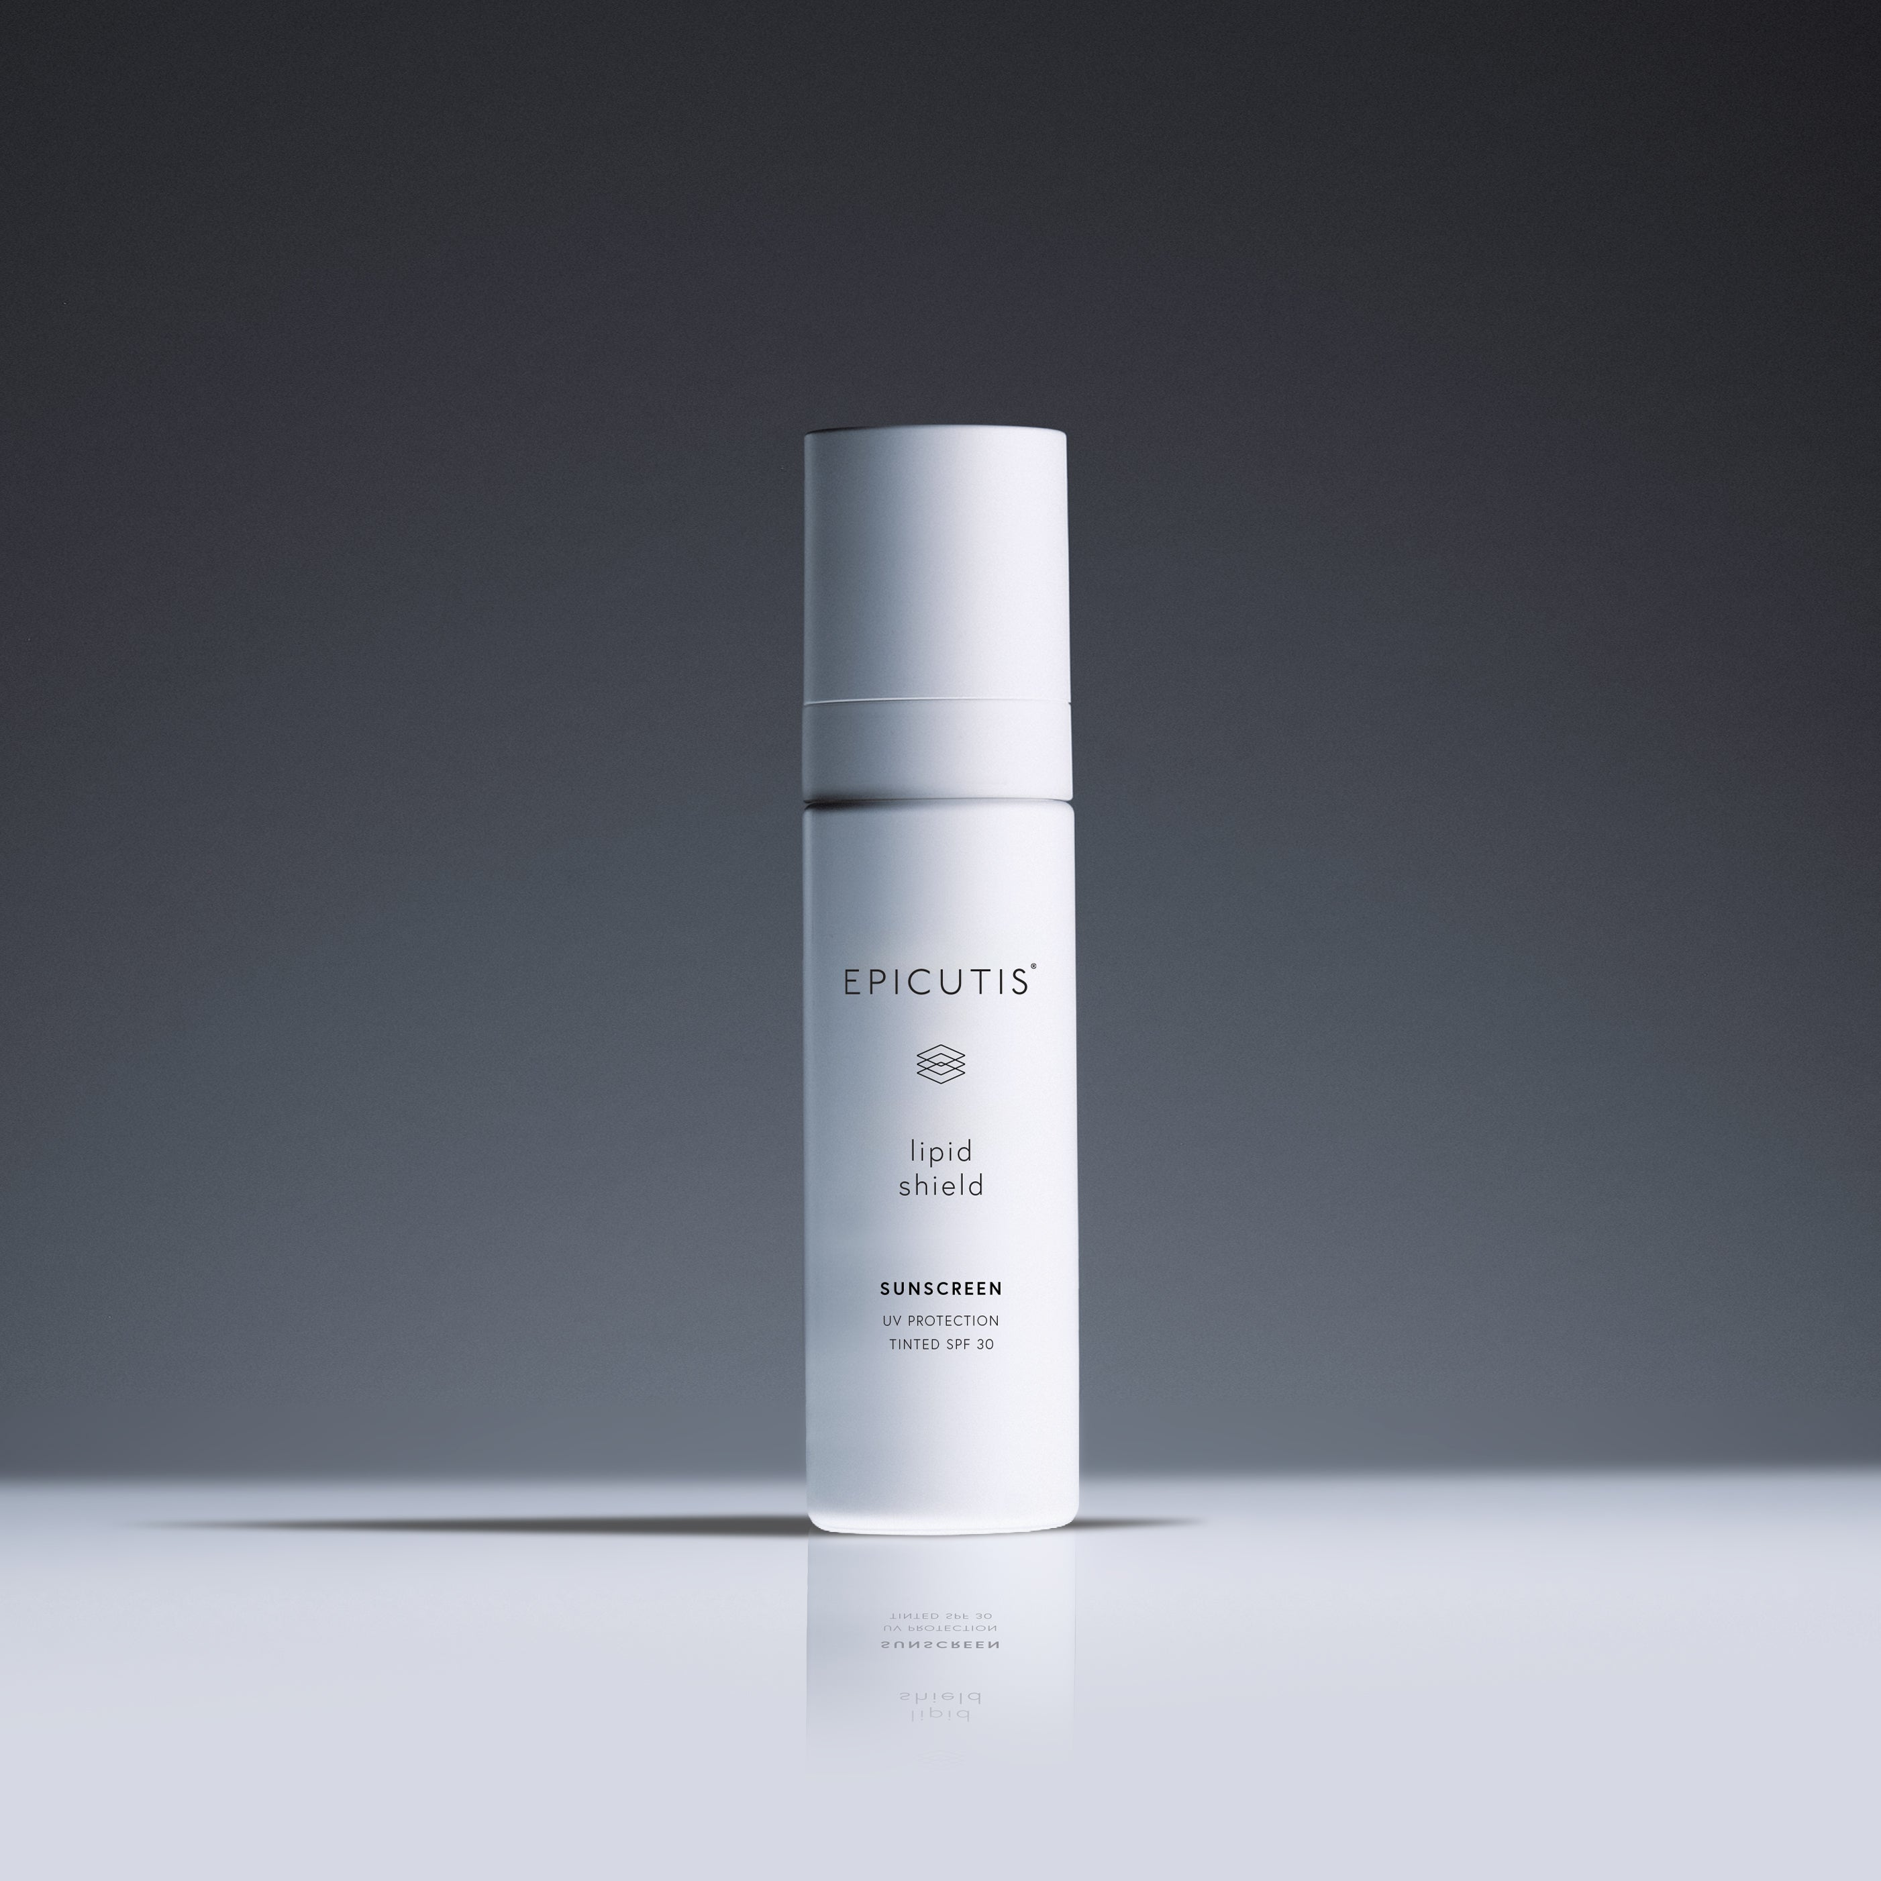
Brand and category EPICUTIS® | The Elixir Vanity > Sun Care
Retail price and size $90.00 USD | 1.7 oz
Contents and specifications One default product listing; no shade selection published.

Website description
Complete your morning routine with a tinted mineral sunscreen featuring 21% zinc oxide and SPF 30. Moisturizing botanicals and TSC complement daily sun protection with skin-conditioning care.
Benefits and concerns Daily sun protection; moisturizing tinted finish.
Featured ingredients Zinc oxide 21%, TSC, aloe, bisabolol, licorice-derived dipotassium glycyrrhizinate.
How to use Apply generously to dry skin 15 minutes before sun exposure. Reapply at least every two hours and immediately after towel drying. The page states reapplication after 80 minutes of swimming or sweating; confirm water-resistance labeling on packaging. Children under six months: ask a doctor.
Full ingredients Active Ingredient - Zinc Oxide 21% Water (Aqua), Caprylic/Capric Triglyceride, Cetearyl Alcohol, Coconut Alkanes, Glycerin, Aloe Barbadensis Leaf Juice, Argania Spinosa Kernel Oil, Glyceryl Caprylate, Coco-Glucoside, Phaeodactylum Tricornutum Extract, Butyrospermum Parkii (Shea) Butter, Helianthus Annuus (Sunflower) Seed Oil, Disodium Tetramethylhexadecenyl Succinoyl Cysteine, Oryza Sativa Starch, Bisabolol, Dipotassium Glycyrrhizinate, Sodium Phytate, Xanthan Gum, Sclerotium Gum, Cetearyl Glucoside, Polyhydroxystearic Acid, Polyglyceryl-3 Polyricinoleate, Isostearic Acid, Lecithin, Dimethicone, Coco-Caprylate/Caprate, Caprylyl/Capryl Glucoside, Caprylhydroxamic Acid,Tocopherol, Beta-Sitosterol, Squalene, Triethoxycaprylylsilane, May Contain: Iron Oxide (CI 77491, CI77492, CI77499)
Label note For external use only; keep out of reach of children. Combine sunscreen with shade, protective clothing, and reduced midday exposure. Obtain the complete current Drug Facts label before publication.
Suggested URL /elixir-vanity/epicutis-lipid-shield
SEO title Lipid Shield SPF 30 | The Elixir Vanity
Meta description Shop Epicutis Lipid Shield SPF 30 at The Elixir Vanity by Velaisance. Explore product benefits, ingredients, and directions.
Image and alt text epicutis-lipid-shield.jpg | EPICUTIS Lipid Shield SPF 30 product packaging.
Source https://epicutis.com/products/lipid-shield | Reviewed October 31, 2026

Hydrobiome Serum
Website SKU EV-EPI-HBS-01
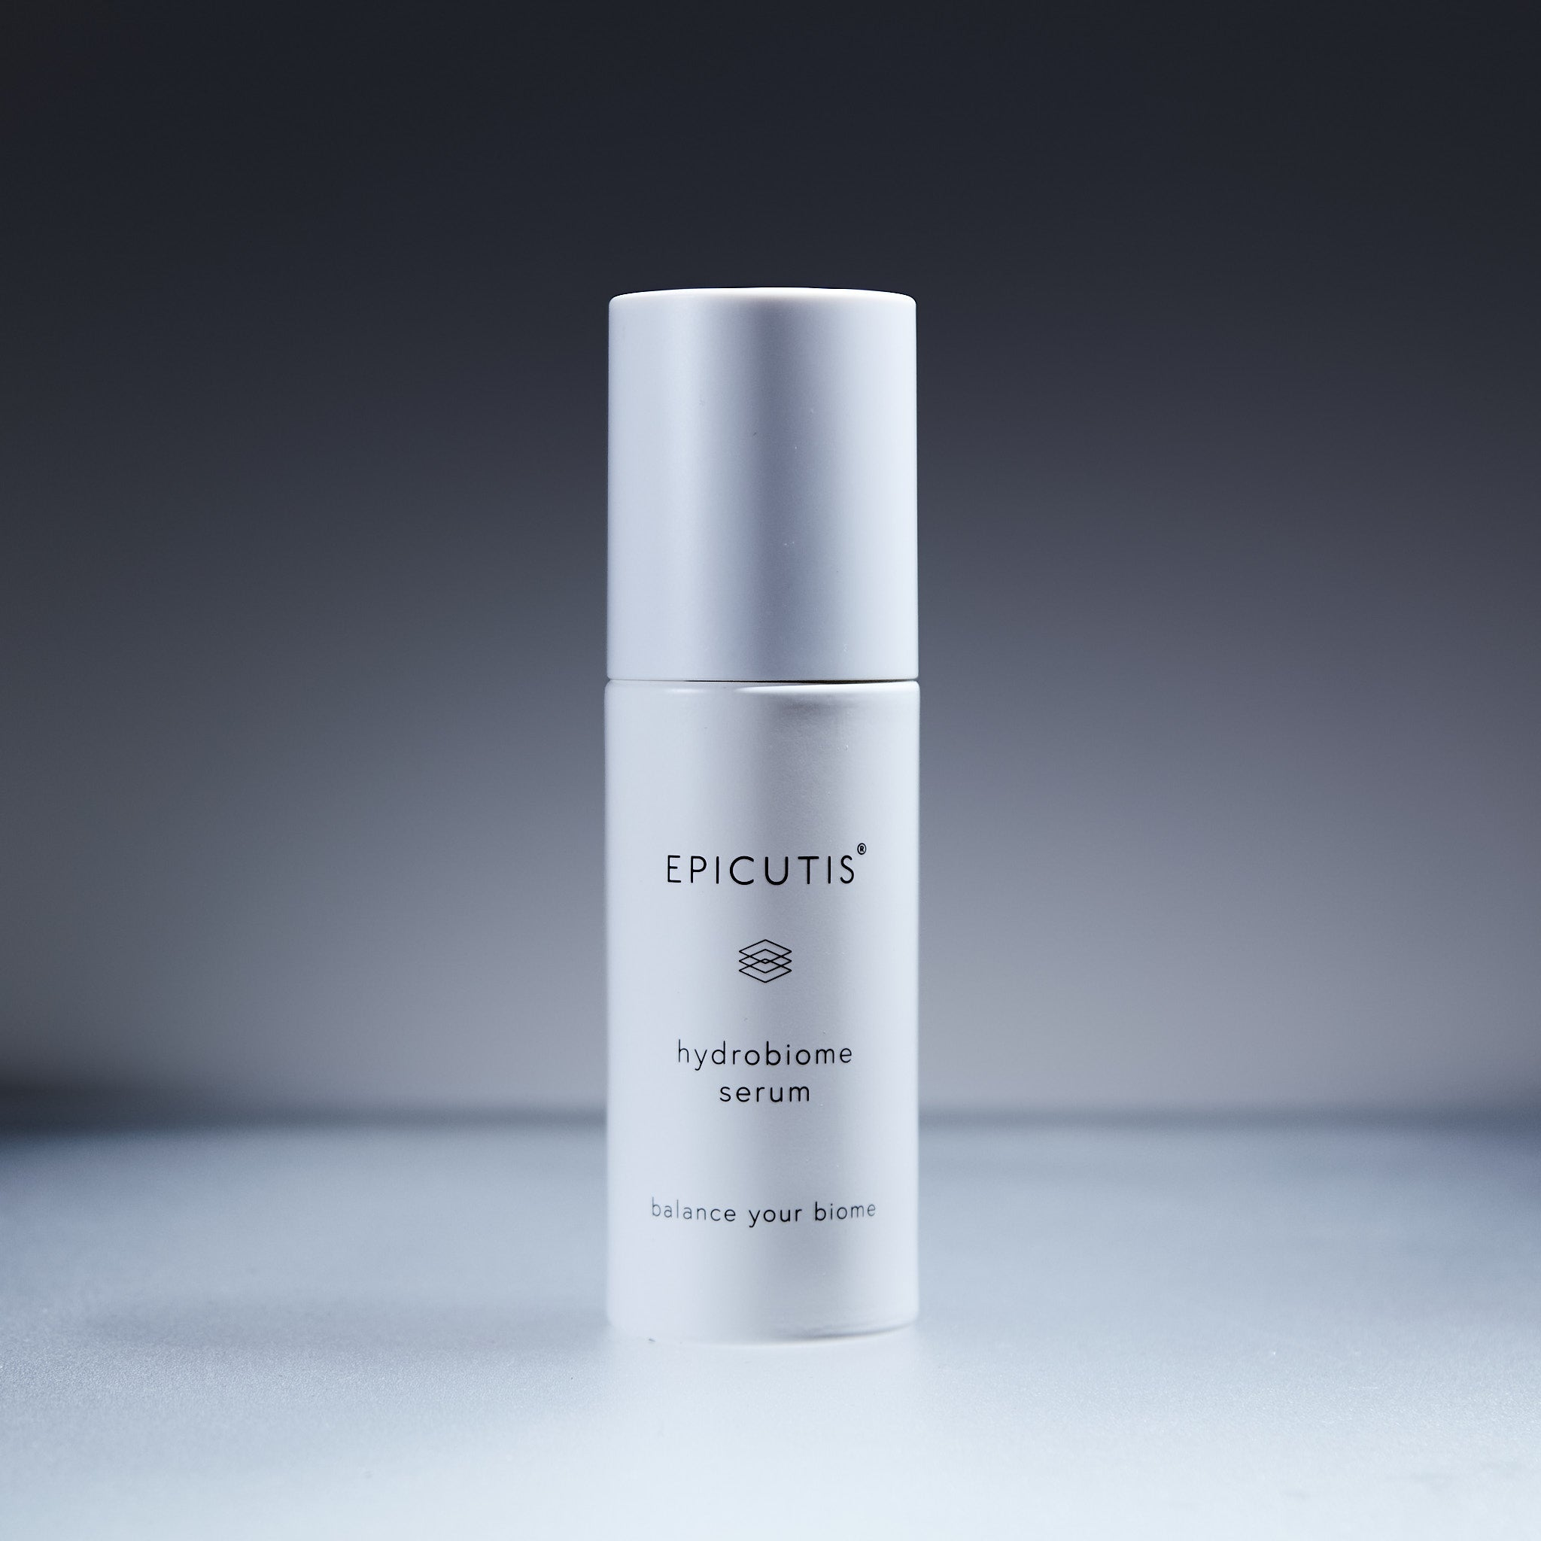
Brand and category EPICUTIS® | The Elixir Vanity > Serums
Retail price and size $165.00 USD | 50 ml / 1.7 fl oz

Website description
Support a calmer-looking complexion with this lightweight serum for microbiome balance and barrier care. TCP, a vitamin E derivative, and sodium hyaluronate deliver moisture and antioxidant support.
Benefits and concerns Barrier support; visible irritation; microbiome balance.
Featured ingredients TCP, sodium tocopheryl phosphate, sodium hyaluronate, propanediol.
How to use Morning and evening, smooth two pumps over the face until absorbed. Add one pump for neck and chest.
Full ingredients Water, Propanediol, Pentylene Glycol, Glycerin, Disodium Tetramethylhexadecenylcysteine Formylprolinate, Sodium Tocopheryl Phosphate, Sodium Hyaluronate, Sodium Phytate, Carbomer, Potassium Hydroxide
Suggested URL /elixir-vanity/epicutis-hydrobiome-serum
SEO title Hydrobiome Serum | The Elixir Vanity
Meta description Shop Epicutis Hydrobiome Serum at The Elixir Vanity by Velaisance. Explore product benefits, ingredients, and directions.
Image and alt text epicutis-hydrobiome-serum.jpg | EPICUTIS Hydrobiome Serum product packaging.
Source https://epicutis.com/products/hydrobiome-serum | Reviewed October 31, 2026

SKU system for The Elixir Vanity
Use EV-BRAND-ITEM-VARIANT for every retail product. The Epicutis SKUs in this guide are now assigned internal Velaisance identifiers. They are not manufacturer SKUs, UPCs, or registered barcodes.
EV The Elixir Vanity store prefix.
BRAND EPI for Epicutis; VEL for Velaisance own-brand products. Assign a new unique brand code for each additional supplier.
ITEM A short, unique product code within the brand. For example, LPS means Lipid Serum.
VARIANT 01 identifies the current sellable size or pack in this guide. Assign 02, 03, and so on to other sizes, shades, scents, or pack counts. Keep a register of what each variant number means.

Rules for every product category
- Assign one unique SKU to each separately stocked and sold variant. A five-mask box and a single mask need different SKUs.
- Give a bundle its own SKU and track its included products separately where your inventory system supports components.
- Keep SKUs stable when prices or product descriptions change. Do not include prices, expiration dates, or temporary promotions.
- Use uppercase letters, numbers, and hyphens only. Never reuse an old SKU for a different product.
- Track supplier item numbers, barcodes, batch or lot numbers, expiration dates, and quantities in separate inventory fields.
- For candles, room sprays, lip gloss, lip balm, journals, affirmation cards, pens, and other retail products, complete the SKU register once the exact product list and sellable sizes, scents, shades, and pack counts are confirmed. No SKUs for those unverified variants have been assigned in this Epicutis guide.
Example for future setup: EV-VEL-CAN-01 could identify one confirmed candle scent and size. This is a format example, not an assigned SKU.

